Name ________________________________
WEDNESDAY

Write the multiplication sentence represented.
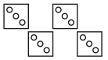
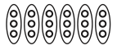
1. 2.

____ groups of _____ ____ groups of _____

_____ x _____ = _____ _____ x _____ = _____

3. 4.

____ groups of _____ ____ groups of _____

_____ x _____ = _____ _____ x _____ = _____

Review

4) What is the difference between 4,082 and 1,937?

5) 6, 4 0 4 6) 3, 7 7 0
- 6 3 2 - 1, 6 3 1

7) Maria has spent 1,054 days in school since kindergarten. Her little brother has spent 716 days in school. How many more days has Maria spent in school than her brother?

www.forrestmath.weebly.com
Multiplication HW #1
THURSDAY
Draw an array to represent the facts below.
1. 2.
3 x 6 = _____
5 x 3= _____

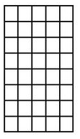
3. 4.

_____ rows of _____ ____ rows of _____

_____ x _____ = _____ _____ x _____ = _____

Review

Circle all of the numbers that round to 3,000.

2,499 3,399 3,092 1,399

2,712 3,951 2,199 2,834

3,567 2, 513 3,709 3,289

