Name _________________________________
MONDAY – Test Practice

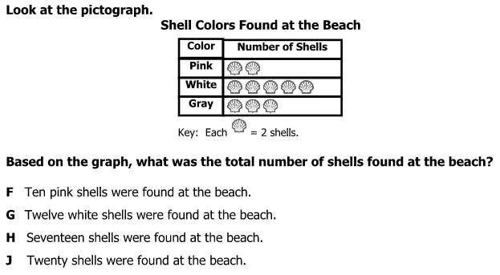

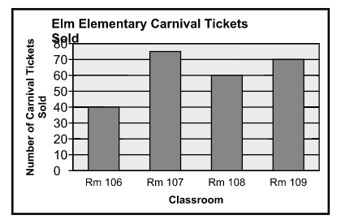

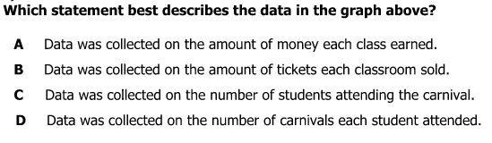
Line Plot HW
TUESDAY
Part I: Creating a line plot
The list below shows the height in inches of each student in Monika’s class.

45, 48, 46, 47, 45, 50, 45, 46, 46, 51, 48, 48, 46

Use this data to create a line plot. Then answer the questions below.

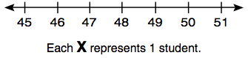

2. How many students are 46 inches tall? _________________

3. How many students are at least 48 inches tall? __________

4. How many students are either 45 or 48 inches? _________

5. How many students are in Monika’s class? ______________

Part II: Second grade review

6) 6 8 7) 5 3 8) 9 0
+ 2 3 - 2 4 - 2 1

www.forrestmath.weebly.com
WEDNESDAY
Part I: Analyzing (understanding) a line plot
The line plot below shows the number of books each student in Tavon’s class read over the summer.

1. What is the most books a student read? ________________

2. How many students read less than 3 books? ____________

Write true (T) or false (F) for each of the following.

________ Two more students read 3 books than 5 books.

________ Seven students read at least six books.

________ There are twenty-five students in Tavon’s class.

Part II: Second grade review

3) Noah was reading a story with Mrs. Tester. The first time he read it, it took him 73 seconds. The second time he read the story it took him 41 seconds. By how much did his second time improve over his first time?

4) Kristen saw a candy bar at the store that she really wanted so she used 3 quarters to buy it. The candy bar cost 53 cents. How much change did Kristen receive?
THURSDAY
Part I: Create and analyze a line plot
The percentages of scores of all the students in a class are shown in the table. Place this data on the line plot below.
Test Scores
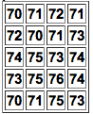

[ccccccc]

76
75
74
73
72
71
70
Each X represents 1 student

1. How many students scored a 75% or higher? ____________

2. Two students scored a _________ percent.

3. How many more students scored a 73% than a 76%? ____

4. What was the lowest score in the class? ________________

5. What was the highest score in the class? _______________

Part II: Second grade review
Directions: How much is each set of coins worth?

6) Qddnppp

7) Qq dddnPp

