Name _________________________________
MONDAY

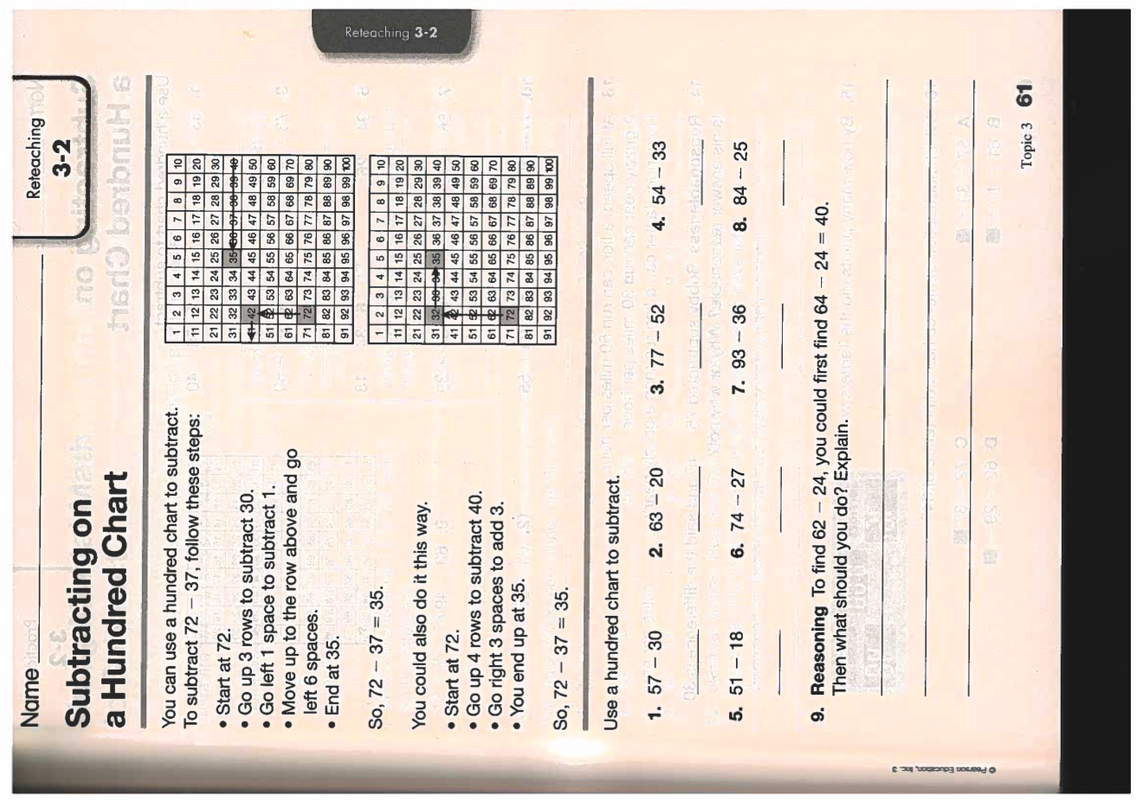

Subtraction HW
TUESDAY

1. 6 7 2 2. 5 2 7 3. 9 2 4 - 3 7 5 - 3 8 9 - 6 7 8

4. 5 8 1 5. 7 1 3 6. 6 2 8 - 2 5 6 - 4 9 8 - 3 7 5

7. Old MacDonald had 379 sheep and 135 chickens. How many more sheep than chickens does he have?

8. Ms. Wilson was cleaning out her closet. She had 14 pairs of sandals, 2 tennis shoes, and 9 pairs of dress shoes. In order to make room in her closet, she donated 6 pairs of shoes to a charity. How many pairs of shoes does Mrs. Wilson have now?

www.forrestmath.weebly.com

WEDNESDAY

1. 4 2 9 2. 7 1 0 3. 4 8 3 - 3 3 6 - 4 6 8 - 2 7 6

4. 4 7 3 5. 8 0 4 6. 7 1 5 - 2 6 7 - 5 6 9 - 4 8 4

7. Jim has two puzzles. The sailboat puzzle has 850 pieces. The balloon puzzle has 375 pieces. How many more pieces does the sailboat have than the balloon puzzle?

1. 5, 6 3 7 2. 8, 0 2 0
- 4, 6 8 2 - 5, 4 7 6

3. 5,332 - 3,914 = ______

Estimate | Actual

THURSDAY
1. 493 - 264 = ______

Estimate | Actual

2. 6,349 - 2,863 = ______

Estimate | Actual

3. There were 3,484 visitors to the zoo Friday morning and 4,323 visitors to the zoo Friday afternoon. On Saturday, 5,837 people came the whole day. How many more visitors came to the zoo on Friday than Saturday?

4. The school library has 2,086 books. If the librarian gets rid of 954 books, how many books does the library have now?

www.forrestmath.weebly.com

