Name _______________________________________
MONDAY
Write the division sentence represented.
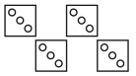
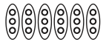
1. 2.

18 ÷ _____ = _____ _____ ÷ _____ = _____
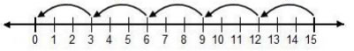
3.

_____ ÷ _____ = _____

4. Draw a picture to solve the problem. Ms. Crump has six pieces of candy to share with her two daughters. If each daughter gets the same amount, how many pieces of candy will they each get?

Review
5. Marcel went to a concert. There were 8,209 total people at the concert and 3,015 of those people were males. How many people were female?

6. 7,813 – 941 = _________ 7. 4,512 + 3,874 = _________

Representing Division HW
TUESDAY
Use the number line to represent the division fact.

1. 8 ÷ 2= _____
[0d1d2d3d4d5d6d7d8d9d1 0d]

2. 9 ÷ 3 = _____
[0d1d2d3d4d5d6d7d8d9d1 0d]

Draw an array or equal groups to represent the facts below.
3. 4.
15 ÷ 5 = _____
20 ÷ 4= _____

Review

5. 5 x 10 = _____ 6 x 2 = _____ 5 x 7 = _____

4 x 1 = ______ 12 x 0 = ____ 2 x 8 = _____

6. Dasani was making goodie bags for her birthday party. If she made six bags and put 5 pieces of candy in each one, how many pieces of candy does she need? Draw a picture to show your answer.

WEDNESDAY
Use the number line to represent the multiplication or division fact.

1. 5 ÷ 1 = _____
[0d1d2d3d4d5d6d7d8d9d1 0d]

2. 2 x 4 = _____
[0d1d2d3d4d5d6d7d8d9d1 0d]

Draw an array or equal groups to represent the facts below.
3. 4.
24 ÷ 4 = _____
14 ÷ 2 = _____

Review
12 x 2 = _____ 8 x 2 = _____ 11 x 0 = ____

10 x 7 = ____ 6 x 5 = ______ 5 x 4 = _____

6. Circle each of the following that have a 7 in the ten thousands place.

278,419 713,389 75,238

627,134 971,238 47,135

THURSDAY
- Explain in your own words how you would multiply a number by 5. For example, how would you solve 4 x 5?

2. What division statement is shown by the representations below?

______ ÷ _____ = _____

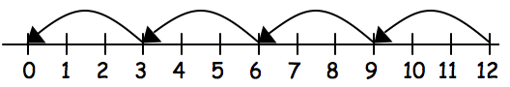
3.

______ ÷ _____ = _____

Review

12 x 2 = _____ 8 x 2 = _____ 11 x 0 = ____

10 x 7 = ____ 6 x 5 = ______ 5 x 4 = _____

5. This table shows the number of books that students checked out and returned at the school library on three days.
Day | Number of Books Checked Out | Number of Books Returned
Tuesday | 247 | 223
Wednesday | 118 | 136
Thursday | 204 | 198
About how many more books were checked out on Wednesday and Thursday combined than on Tuesday?

