Name _______________________________________
MONDAY
Part 1: Write what fraction of each shape is shaded.

Part 2: Shade the figures to show the fraction below it.
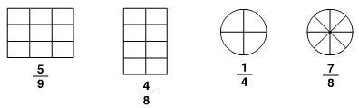

Review
Write the time shown on each of the clocks.
awQ awR a
h h h

Round each of the following to the place value below the number.

6,206 4,825 7,099 hundreds place thousands place tens place

__________ __________ _________

Fraction HW
TUESDAY
Part 1: Write what fraction of each shape is shaded.

Part 2: Shade the figures to show the fraction below it.
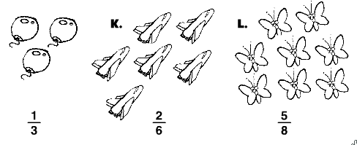

Review
Write an example for each of the following.
Property | Example
Identity property of addition
Identity property of multiplication
Commutative property of addition
Commutative property of multiplication

Maria and Nicky picked tomatoes in their vegetable garden. Maria picked 49 tomatoes and Nicky picked 62. If they used 25 tomatoes to make pasta sauce how many did they have left?
www.forrestmath.weebly.com Twitter @ForrestMath1406

WEDNESDAY
A fraction model is drawn inside each box. Name the fractional part that is shaded.

Fraction: _________ Fraction: _________

3. Shade each model to represent the fraction or mixed number written below each box.
" " " "

Fraction: Fraction:
one and two fourths three and two tenths
Review
Fill in the chart using elapsed time.

Start Time | End Time | List the hours | Elapsed Time
!  ___:______ | $  ___:______
4:05 p.m. | 8:05 p.m.
THURSDAY
www.forrestmath.weebly.com Twitter @ForrestMath1406
Shade each model to represent the fraction or mixed number written below each box.
iii
iii

Fraction:

Fraction: Fraction:
one and one fourth two and five eights

Answer the following questions below.
1. Rowena puts 7 socks in the washing machine. Four of them are black and 3 are white.

What fraction of the socks is black? _________________

What fraction is white? ________________

Review
1. There was a fire in the building down the street. It was so large that our city had to call in 6 fire trucks. Each truck had 9 firemen riding on it. How many firemen arrived to fight the fire?

2. Hunter works at the zoo. He fed the moose breakfast, put a loose duck back in the pond, and fed 7 tigers. He worked 5 hours. If he is paid 5 dollars per hour, how much money did he make?

3. Emily and Morgan are making teddy bears. They will take the teddy bears to the Children's Hospital. Sick children will get the bears. So far they have made 13 bears. They use 2 buttons on each bear's shirt. How many buttons have they used in all?

4. Kevin hung up 24 towels. If each clothesline held 8 towels, how many clotheslines were needed?

