Name _________________________________
MONDAY – Unit #2 Review

Part I: Round each number to the nearest hundred.

1) 4,652 2) 7,390 3) 983

4) 8,344 5) 1,296 6) 9,381

Part II: Estimation

7. When rounding to the nearest hundred, what is the best estimate of 4,652 + 1,296?

A) 5,900 B) 6,000 C) 6,100 D) 6,200

8. When rounding to the nearest hundred, what is the best estimate of 7,390 + 983?

A) 8,200 B) 8,300 C) 8,400 D) 8,500

Part III: Addition/Subtraction

9) 3,348 10) 7,201 11) 5,072
+ 2,791 + 2,689 - 2,157

12) 3,456 12) 536 13) 583
- 1,654 + 381 - 391

Graphing HW
TUESDAY
Part I: Vocabulary

survey table bar data axis

1) We use bars to show data in a ____________ graph.

2) You can collect data to display in a graph by conducting a
_________________.

3) Information collected in a survey and then displayed in a graph is called
_________________.

4) Before I create my graph, I can organize data using a
_________________.

Part II: Analyzing (understanding) a bar graph.

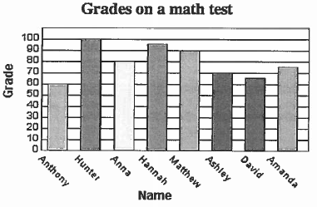

Scan me!

5. What scores did Hannah receive on her test? _________________

6. How much higher did Matthew score than David? _______________

7. What is the combined score for Anthony, Hunter, and Ashley?
___________________

8. How many students took the test? ________________

www.forrestmath.weebly.com
Bar Graph HW
WEDNESDAY
Part I: Parts of a bar graph
Directions: Using the graph below, identify the following parts of a bar graph.

1) Circle the title of the graph
2) Put a box around the axis labels
3) Choose any color and shade the bars that show the data
4) Put a star by the scale. What increment is the scale counting by? _____

Part II: Analyzing (understanding) a bar graph.
Directions: Use the graph from Part I to answer the questions below. Write true (T) or false (F) for each of the following based on the information in the graph.

1. _________ Anna scored twenty points more than Anthony.

2. _________ Ashley scored thirty points less than Matthew.

3. _________ Hunter and Hannah had the two highest scores in the class.

4. _________ There is a larger difference between Hunter and Anna’s test scores than between Matthew and Anthony’s.

5. Write a TRUE statement comparing David and Hannah’s test scores.
__________________________________________________________________________________________________________________________________________________________________________________________

THURSDAY
Part I: Create a bar graph
Directions: Using the information from the table, create a bar graph to
show the data collected. Be sure to include the following parts of a bar graph: title, axis labels, bars (data), scale, and categories.
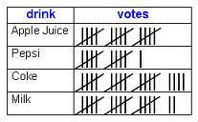
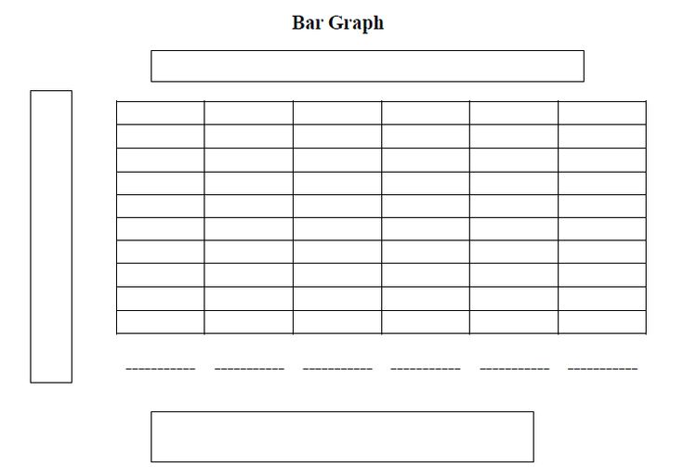

1. Which of the following survey questions could have been used to collect data for this graph? Hint: there may be more than one correct answer choice

- How many drinks did Sally have last Tuesday?
- What is your favorite drink to have at lunch?
- What drink goes best with pizza?
- Coke is better than Pepsi.
- How much does milk cost at lunch?

