Name _________________________________
TUESDAY
Directions: Solve each of the following.
B - X
1.
=

Y - E
2.

=

o + p

3.
=

Review
The animal park has 12 zebras, 25 monkeys, and some giraffes. If the total number of zebras, monkeys, and giraffes at the park is 50, how many giraffes are there?

Write what time is shown on each clock below.
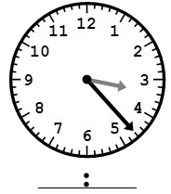
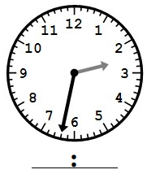
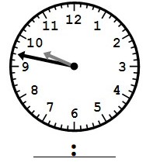

Add/Sub Fractions HW2
WEDNESDAY
Directions: Solve each of the following.
1. 2^ + 2^ 2. 2# + 1# 3. 3% + 3%
gg

d
y

1. 6* - 2* 2. 3$ + 3$ 3. 6! ) - 2! )
K
v
v
K

Review
1. On Friday 269 people visited the Norfolk Zoo. On Saturday, 674 people visited. What is the best estimate of the total number of people that visited the zoo on those two days?

2. Ms. McCord will be on vacation for two weeks. How many days will she be gone in all? _______________

3. Mrs. Beaumont will have a first birthday party for Baby Laila. If she is one year old, how many months old is she? ________

4. You are at school for about 7 hours a day. How many minutes a day do you spend learning from your FABULOUS teachers? ______________________

5. 48 ~ 8= _____ 6. 16 ~ 4= ____ 7. 16 ~ 2= ____
THURSDAY
Directions: Solve each of the following. Use the grid paper to change improper fractions into mixed numbers.

1. 2* + 7* 2. 3$ + 3$ 3. 5^ + 3^

Review
Directions: Write a mixed number and improper fraction for the models below.
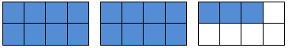
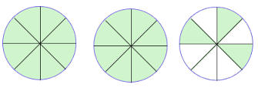
4. 5.

5. Eric bought a bike that cost $240 and a washing machine for $395. If Eric had $1000 saved, how much money does he have left after his purchases? (2 steps!)

www.forrestmath.weebly.com
Directions: Solve each of the following. Use the grid paper to change improper fractions into mixed numbers when necessary.

1. 3! ) + 4! ) 2. 8! @ - 5! @ 3. 3$ + 2$

Review
4. Derek had 45 games. He gave 14 games to his friend, Steve. Then Derek got 13 more games for his birthday. How many games does Derek have now? (2 steps!)

5. Write six hundred five thousand, three hundred eleven in standard form _____________________________________

6. Use (> < =) to compare thirty-five thousand, twenty-two and three hundred five thousand, two hundred twenty-two.

7. Round the following numbers to the nearest ten thousand.

905,591 93,701 6,011

