Name _______________________________________
MONDAY
Directions: Solve each of the following. Use the grid paper to change improper fractions into mixed numbers.

1. 2* + 7* 2. 3$ + 3$ 3. 5^ + 3^

Review
Directions: Write a mixed number for the models below.
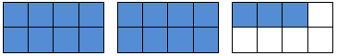
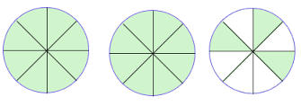
4. 5.

5. Eric bought a bike that cost $240 and a washing machine for $395. If Eric had $1000 saved, how much money does he have left after his purchases? (2 steps!)

www.forrestmath.weebly.com Twitter @ForrestMath1406

More Add/Sub Fractions HW
TUESDAY
Directions: Solve each of the following. Use the grid paper to change improper fractions into mixed numbers when necessary.

1. 3! ) + 4! ) 2. 8! @ - 5! @ 3. 3$ + 2$

Review
4. Derek had 45 games. He gave 14 games to his friend, Steve. Then Derek got 13 more games for his birthday. How many games does Derek have now? (2 steps!)

5. Write six hundred five thousand, three hundred eleven in standard form _____________________________________

6. Use (> < =) to compare thirty-five thousand, twenty-two and three hundred five thousand, two hundred twenty-two.

7. Round the following numbers to the nearest ten thousand.

905,591 93,701 6,011

WEDNESDAY
Directions: Solve each of the following.
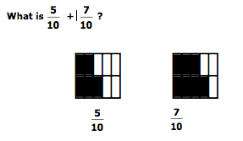
1)

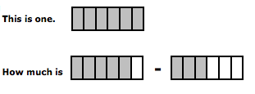
2)

Review
The animal park has 12 zebras, 25 monkeys, and some giraffes. If the total number of zebras, monkeys, and giraffes at the park is 50, how many giraffes are there?

Write what time is shown on each clock below.

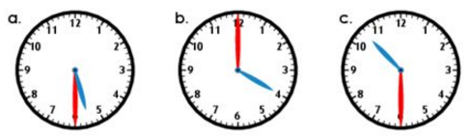

___________ ___________ ___________
THURSDAY
Directions: Solve each of the following.

1. 3! @ + 9! @ 2. 4^ - 3^ 3. 4$ - 2$

Directions: Name the following mixed numbers

4)

5) 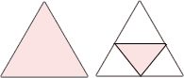

Review
6. On Friday 269 people visited the Norfolk Zoo. On Saturday, 674 people visited. What is the best estimate of the total number of people that visited the zoo on those two days?

7) 3 5 8) 8 1 9) 7 6
x 4 x 3 x 9

10. 48 ~ 8= _____ 11. 16 ~ 4= ____ 12. 16 ~ 2= _____
www.forrestmath.weebly.com Twitter @ForrestMath1406

