Name __________________________________
MONDAY

Count the coins. Circle the amount that is greater.
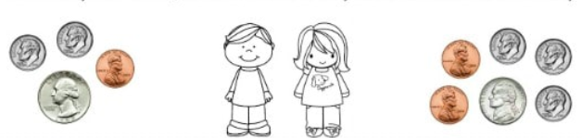
1.

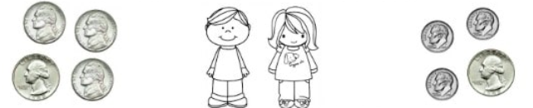
2.

Count the coin and bill collections. How much money is in each collection?
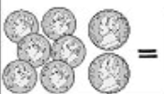
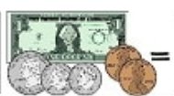
3. 4.

Questions 5-8

How much money is each set worth?
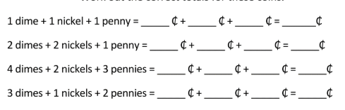

Time/Money Review HW
TUESDAY
Match the time with the correct clock.

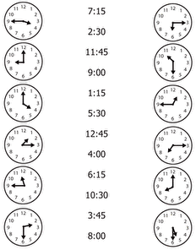

I have $1.56 in my pocket. Draw the coins/bills that I could have.

www.forrestmath.weebly.com
WEDNESDAY
Review vocabulary for telling time. Write the matching letter(s) on the correct line(s).
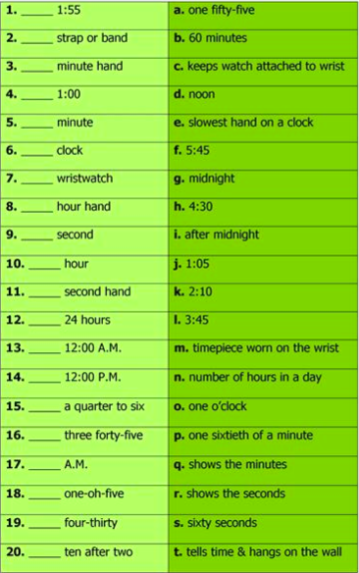
THURSDAY
You are shopping at the Snack Shack with the coin sets below. What can you buy with each set?
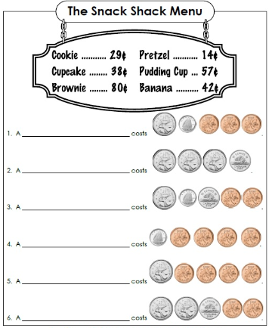

Count and compare the coin collections.
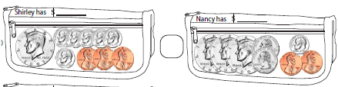
7.

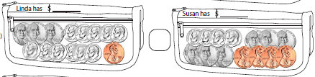
8.

