Name ________________________________
MONDAY

Part I: Name the type of clocks shown.

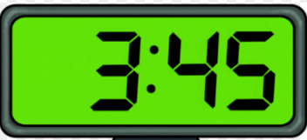
2
_____________ ______________

Part II: Write a sentence about how you can tell the hour hand and minute hand apart.

____________________________________________________________________________________________________________________________________

Part III: Tell time on an analogue clock

1) 4 2) & 3) {
www.forrestmath.weebly.com

Telling Time HW
TUESDAY

Part I: Tell time on the analogue clocks below.

1) W 2) = 3) 6

Part II: Match the digital clock to the correct analogue clock.
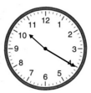
3:10

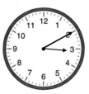
1:30
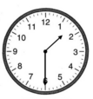
10:20

WEDNESDAY

Part I: Draw the hands on the clock to show the correct time.

1) a 2) a
2:05 7:35

3) a 4) a
9:55 8:00

5) a 6) a
3:30 5:20

THURSDAY
Review

Part I: Add or Subtract

7) 2 0 8) 4 2 9) 6 4 10) 8 4
+ 7 1 + 4 3 - 1 6 - 4 1

Part II: Round the following numbers to the nearest ten.

59 ______ 94 _______ 22 _______

75 ______ 98 _______ 64 _______

Part III: Circle the numbers below that would NOT round to 30.

35 36 32 29

31 23 25 27

15 28 24 33

www.forrestmath.weebly.com

