Name _________________________________
MONDAY
Part I: Match the solid shape with its’ name:

Cube

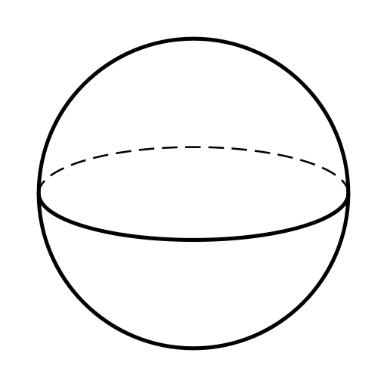
Rectangular Prism

Sphere

Part II: Describe the following solid figures:

Cube: ____ faces Sphere: ____ faces
____ edges ____ edges
____ vertices ____ vertices

Rectangular Prism: ____ faces
____ edges
____ vertices

Part III: Circle each matching shape
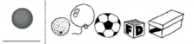
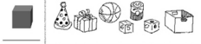
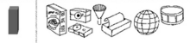

Solid Figures and Symmetry
TUESDAY
1. Which of the following is true about rectangular prisms?

A) Has 12 edges B) Has 8 faces

C) All faces are congruent D) Has 6 vertices

2. Noah was thinking about rectangular prisms while he was at the grocery store with his mom. Which of the following items is a rectangular prism?

A) A roll of paper towels B) A can of soup

C) A cereal box D) A soda bottle

3. Claire went home and decided to see how many spheres she could find in her house. Circle all of the following that are spheres:

basketball car tire orange

banana baseball marble

4. If you trace any face of a cube, you will get a -

A circle C square
B triangle D sphere

5. A cube and a rectangular prism both have-
F 8 faces
G 6 edges
H 8 vertices
J 8 edges
WEDNESDAY
1. Josh folded these six squares to form a solid figure.
What solid figure did he make?

F cube G rectangle

H square J sphere

2. Spencer folded these four rectangles and two squares to form a solid figure. What figure did he make?

A cube

B rectangle

C rectangular prism

D square

3. Look at the square below.

How many lines of symmetry can be drawn in this square?

F one H three
G two J four

THURSDAY
1. Bill drew four examples to show lines of symmetry for a circle. Which of the following is NOT correct?

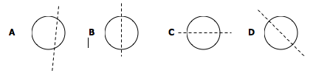

2. Circle the shapes that have EXACTLY one line of symmetry?

3. 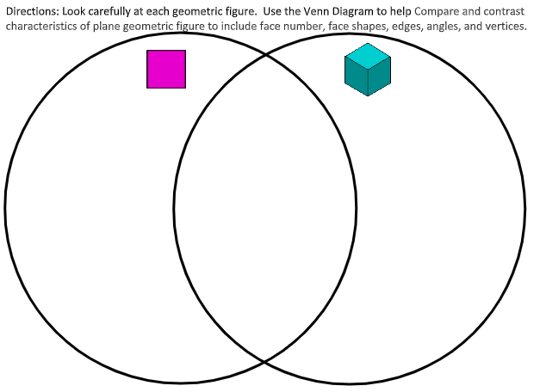

www.forrestmath.weebly.com

