Name _________________________________
Monday
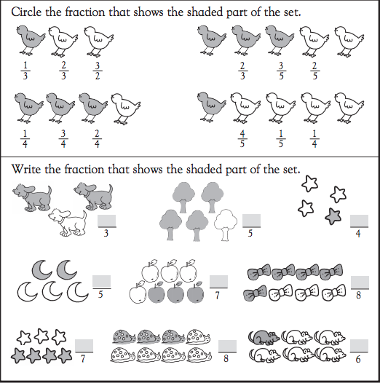

Part II: Solve the following subtraction problems by regrouping.

pPPPPK – PP l =

www.forrestmath.weebly.com
Fractions of a Set
TUESDAY
Write the fraction of the number that is shaded.
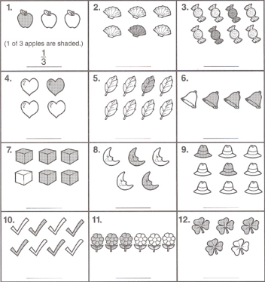
Part II: Solve the following subtraction problems by regrouping.

ppppppps – ppppm =

WEDNESDAY
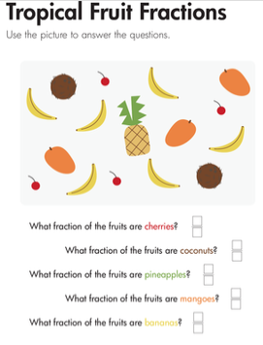
Part II – Answer the following word problem. Show your math work.

Haley is a superhero. Last week, she rescued a total of 52 people from danger. If Haley rescued 39 children, how many adults did she rescue?

THURSDAY

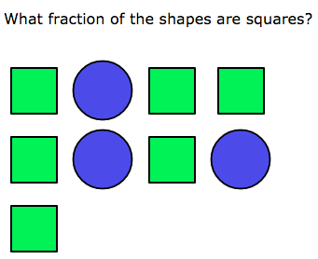
A) 3(

B) 6(

C) 3^

D) 6#

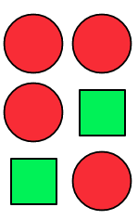
What fraction of the shapes are circles?

_____

There were 4 squirrels in a tree. 2 ran away.
What fraction of the squirrels were left?

____

There were 3 bugs on a leaf. 2 flew away.
What fraction of the bugs flew away?

____

