Name _________________________________
WEDNESDAY

Directions: Use the hundred chart below to identify the number that is 1 more, 1 less, 10 more, and 10 less than the number given.
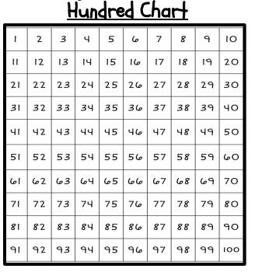

Place Value HW #1
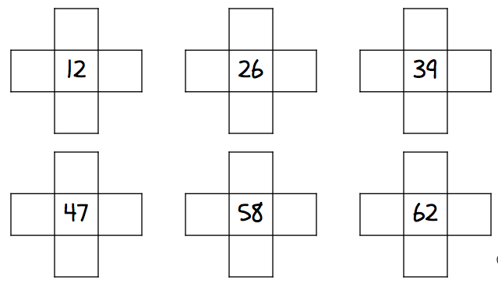

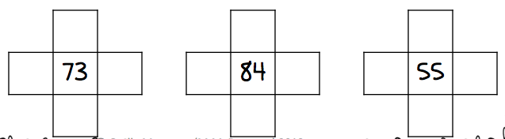

Review – find the difference of the following

1. ka - m =

2. vzcb - f =

www.forrestmat.weebly.com
THURSDAY
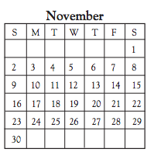
Directions: fill in the chart below to show 10 more, 10 less, 100 more, and 100 less than the numbers given.
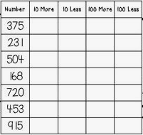

Basic Computation Review

1. What is the difference between 14 and 5? ________

2. What is seven less than ten? ________

3. What is 17 minus 11? ________

4. What is five fewer than twelve? _______

Calendar Review

4. Harper’s birthday is on November 24th. What day of the week is November 24th?
___________

5. Thanksgiving is on the last Thursday in November. What date is Thanksgiving according to this calendar?
____________

6. Thanksgiving break lasts for 5 days total. If the last day of Thanksgiving break is Sunday, November 30th, what is the first day of Thanksgiving break?
_________________

7. There are 30 days in November, how many full weeks are in November? ___________

Basic Computation Review

1. If I double the number 7, the sum will be ________

2. What is three more than eight? _______

3. What is five less than 16? ______

4. The sum is: ________________________________________

5. The difference is: ___________________________________

www.forrestmath.weebly.com

