Name _________________________________
MONDAY

Part I: Draw the following plane figures:

Triangle | Rectangle | Square

Part II: Describe the following plane figures:

Triangle: _____ sides Rectangle: _____ sides

_____ angles _____ angles

Square: _____ sides

_____ angles

Part III: Circle each matching shape
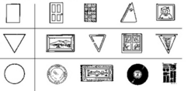

Plane Figures and Symmetry HW
TUESDAY
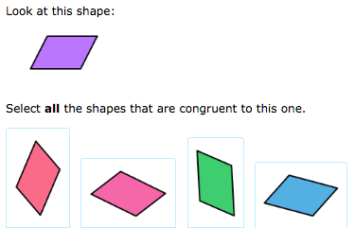

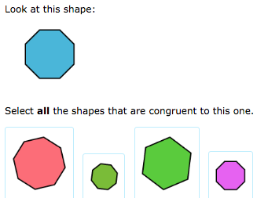

www.forrestmath.weebly.com
WEDNESDAY

