Name _________________________________
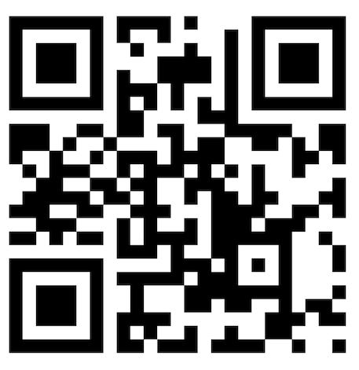
MONDAY
Part I: Understanding place value blocks.
Match the blocks with their name.

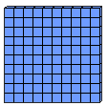

ones/unit tens/rod hundreds/flat

Part II: Write the standard form of each number.

1. n ______

2. u _______

www.forrestmath.weebly.com
Place Value HW
TUESDAY
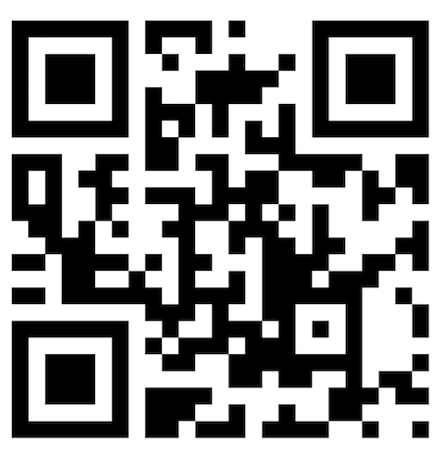
Part I: Draw the following numbers using place value blocks.

1. 321

2. 57

3. 192

4. 206

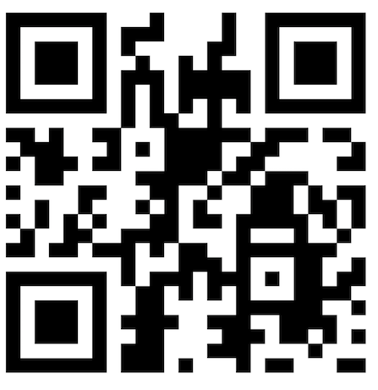
Part II: Write the following numbers in word form

5. 39 _______________________________________________

6. 181 ______________________________________________

7. 50 _______________________________________________

8. 577 ______________________________________________

9. 302 ______________________________________________

WEDNESDAY
Part I: Identify the place and value of the underlined digit.

Number | Place | Value
Ex. 571 | Tens | 70
122
698
44
1,965
430

Part II: Identify the hundreds, tens, and ones in each number.

Ex. 561 = 5 hundreds, 6 tens, 1 one.

6. 888 = ____________________________________________

7. 53 = ____________________________________________

8. 470 = ____________________________________________

Part III: Identify the number being described.

Ex. 5 hundreds, 6 tens, 1 one = 561

9. 4 hundreds, 3 tens, 9 ones = ________________

10. 8 tens, 2 ones = _______________

11. 9 hundreds, 8 ones = ________________

THURSDAY – Test Practice

1. Which model represents 355?

A) ! ! ! ppppp xc
B) ! ! ! ! ! ppp xc
C) ! ! ! ppp xc
D) ! ! ! ! ! pppc

2. How many TENS are in the model below?

gg gg gg gg gg gg

F 120 H 12
G 60 J 6

3. What is the word name for the number 467?

F four hundred seventy-six
G four hundred sixty-six
H four hundred sixty-seven
J four hundred seventy-seven

