Name _______________________________________________
MONDAY
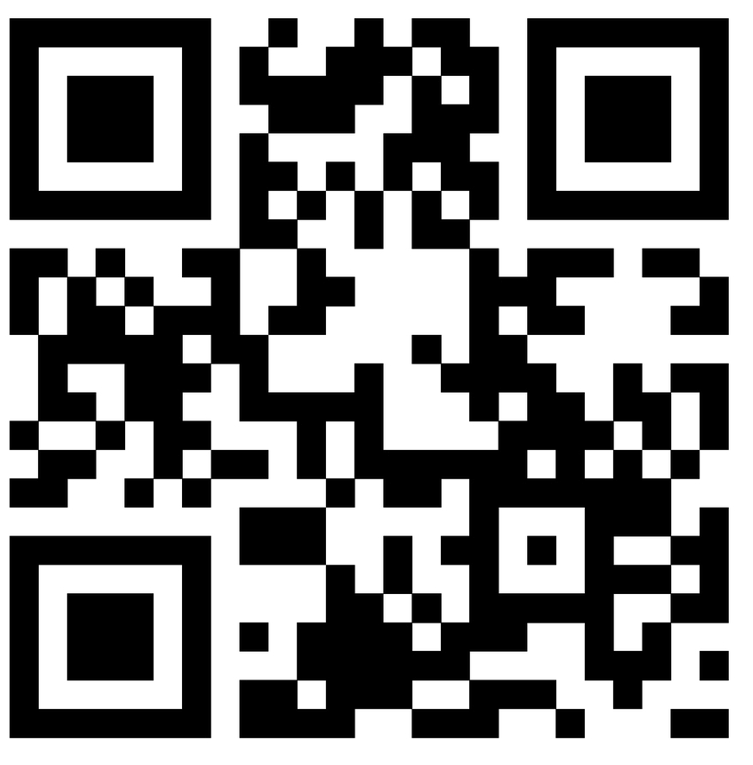
Directions: Count up the following sets of bills/coins. Write the amount on the line using the $ or c correctly.

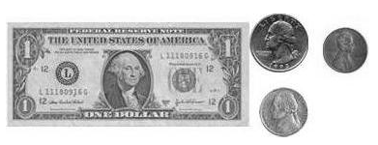
1)

__________________

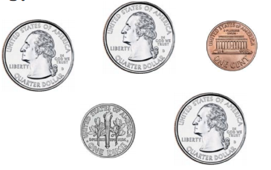
2)

_________________

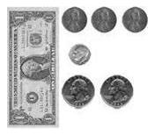
3)

_______________

MONEY HW #2
TUESDAY
Directions: Count and compare the money shown below.

1) Shade the set of coins that is the least
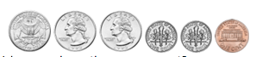

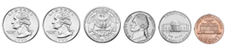

2) Shade the set of money that is greater
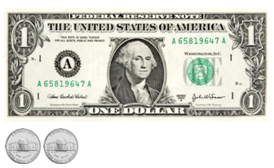

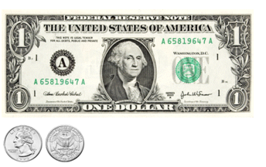

WEDNESDAY
Directions: Find the set that shows an equal amount.

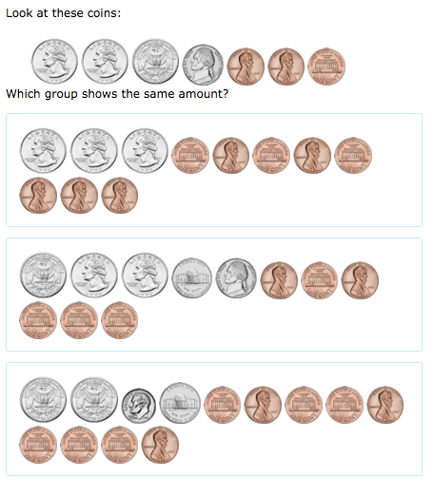

Review: Find the sum.

1) 5 8 2) 4 3 3) 7 7
+ 3 7 + 4 9 + 2 3

www.forrestmath.weebly.com
THURSDAY
Directions: Let’s go shopping! Count up the amounts given and match them to the items in the store.
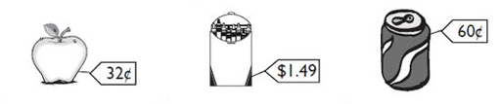

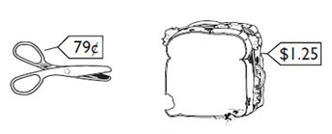

Write the name of the item that matches on the line.

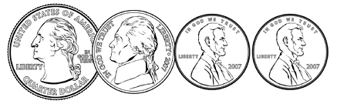
1)

________ ________________

2) QnnnNdd
________________________

3) f dnNppppp
____________________

