Name _________________________________
MONDAY
Part I: Identify the parts of the ruler
Circle each inch
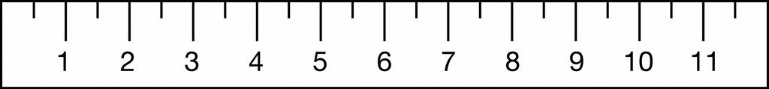

Circle each centimeter

Part II: Circle the ruler that is being lined up correctly
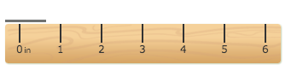
a)

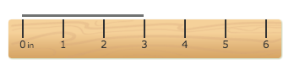
b)

How did you choose your answer? _______________________
____________________________________________________

Part III: Measure to the nearest inch.
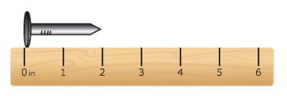
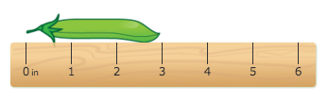

______ inches _____ inches

www.forrestmath.weebly.com
Measuring Length HW
TUESDAY
Part I: Circle the ruler that is being lined up incorrectly.
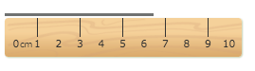
a)

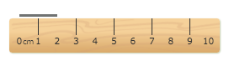
b)

How did you choose your answer? _______________________
____________________________________________________

Part II: Measure to the nearest centimeter
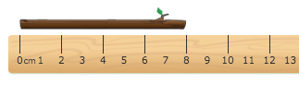

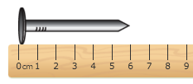
____ cm

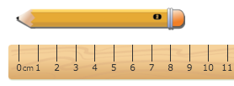
______ cm

______ cm

WEDNESDAY
Part I: Use the ruler provided by your teacher to measure each figure to the nearest inch.

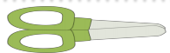
1) _____ inches

2)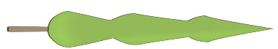

______ inches

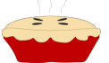
3)

______ inches

4)

______ inches

THURSDAY
Part I: Use the ruler provide by your teacher to measure each figure to the nearest centimeter.

1) ______ centimeters

2)

______ centimeters

3) ______ centimeters

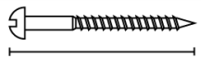
4)

______ centimeters

