Name ______________________________
TUESDAY
Part I: Complete the 100s chart by filling in the missing numbers.
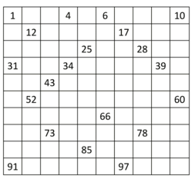

Part II: Group the blocks into tens and ones, how many blocks are there?
q q q q q q q q q q q q q q
q q q q q q q q q q q q q q

First Grade Review HW
WEDNESDAY
Part I: Match the symbol with the correct vocabulary word.

1. - equal sign

2. + subtraction sign

3. = addition sign

Part II: Complete the following addition and subtraction problems.

4) 6 + 5 = ______ 5) 11 – 5 = ______

6) 14 + 2 = ______ 7) 16 – 14 = ______

8) 1 + 9 = ______ 9) 10 – 1 = ______

Part III: Write the correct numeral for each of the following…

10. Fifty-three _________ 11. Twelve _________

12. Twenty-two ________ 13. One ______

14. Fourteen ________ 15. Ninety-nine _______

Part IV: Choose the corresponding subtraction fact.

3 + 7 = 10

a) 7 – 4 = 3 b) 10 – 3 = 7 c) 7 – 3 = 4

www.forrestmath.weebly.com
THURSDAY
Part I: Count the place value blocks below and write each amount as a number.

1. pppg _____

2. ppppph _____

3. ppppa _____

4. pl _____

Part II: Tell the time on each analogue clock

5. w 6. p 7. Y

________ _________ __________

www.forrestmath.weebly.com
Use the space provided to tell you teacher what you think about math.

Dear ______________________,

I think that the easiest part of math is ____________________
____________________________________________________________________________________________________________________________________________________________

I think that the hardest part of math is ____________________
____________________________________________________________________________________________________________________________________________________________

I like to help my classmates when ________________________
____________________________________________________________________________________________________________________________________________________________

I need help when _____________________________________
____________________________________________________________________________________________________________________________________________________________

