Name ____________________________
MONDAY
Directions: Label the following geometric patterns.

1) qQqQqQ
_____ _____ _____ _____ _____ _____

2) b T T b T T
___ ___ ___ ___ ___ ___ ___ ___

3) Bobby made this pattern by repeating the
first four shapes in the order as shown.

The pattern continues in the same way. What will be the next shape in Bobby’s pattern?

A C

B D

4) Look at the pattern of blocks below.

?

Term 1 Term 2 Term 3 Term 4 Term 5
How many blocks should be in Term 5? ________

www.forrestmath.weebly.com
Patterns HW
TUESDAY
Directions: If the pattern continues…

1) If the pattern continues, describe what the next 3 shapes would be.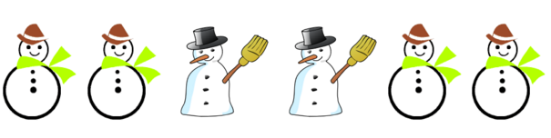
____________, ____________, ____________

2) If the pattern continues, describe what the next shape would be.
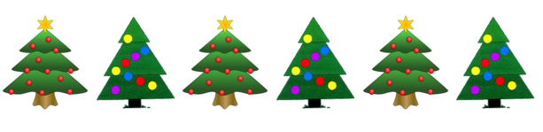
___________________________________________________

3)

If this growing pattern continues, how many squares will
be in the next figure?

F 10 H 16

G 13 J 21
WEDNESDAY
Part I: Geometric Patterns
Directions: Label the pattern and then find the set that shows the same pattern.

1) Which of the following has this same pattern?

F

G

H

J

Part II: Numeric Patterns

2) What is the rule for the pattern below?

5 | 10 | 15 | 20 | 25

F subtract by 2 H add 5

G subtract by 5 J add 30
THURSDAY
Directions: skip count by 2, 5, or 10.

1) Starting at the number fourteen, skip count by two.

______, ______, ______, ______, ______, ______, ______

2) Starting at the number 35, skip count by five.

______, ______, ______, ______, ______, ______, ______

3) Starting at the number twenty, skip count by ten.

______, ______, ______, ______, ______, ______, ______

Circle all of the following that are NOT correctly counting by twos:

4 6 8 10 12 15 18 20

64 66 68 70 72 74 76 78

20 25 30 35 40 45 50 55

70 72 74 76 78 80 82 84

www.forrestmath.weebly.com

