**Name ________________________________**

**MONDAY – Review**

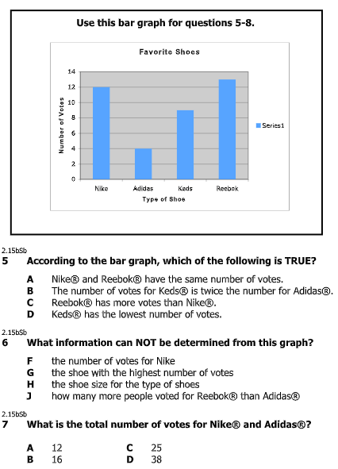





**Equality HW**

**TUESDAY**

**Part I: Define equality and inequality.**

1) In your own words, tell me what it means when a number sentence shows equality _______________________________

________________________________________________________________________________________________________

2) In your own words, tell me what it means when a number sentence shows inequality ______________________________

________________________________________________________________________________________________________

3) Draw the symbol for equality -- _________

4) Draw the symbol for inequality -- _________

**Part II: Circle all of the number sentences that show equality.**

18 + 2 = 20 15 + 2 = 18 4 + 4 = 8

8 – 5 = 2 24 – 10 = 34 22 – 6 = 16

14 + 3 = 17 19 – 7 = 13 31 – 7 = 28

[www.forrestmath.weebly.com](http://www.forrestmath.weebly.com)

**WEDNESDAY**

**Part I: Which sign (> < =) makes the statements true?**

1) 15 + 15 _____ 15 + 15

2) 10 _____ 10 – 7

3) 14 – 2 _____ 14

4) 1 + 0 _____ 1

5) 8 + 11 _____ 22 – 3

**Part II: What number makes the statements true?**

6) 15 + ____ = 20 – 3

7) 13 – 8 = _____ + 0

8) 10 + 10 = _____ - ______

9) _____ - 4 = 8 + 8

10) 9 – 6 = ____ + 1

**Part III: Circle all of the number sentences that show inequality. Change the = to a** ≠ **when you come across an inequality.**

18 + 2 = 20 – 2 15 + 2 = 4 + 4

24 – 10 = 14 + 0 7 + 3 = 5 + 6

**THURSDAY**

**Part I: Answer the following questions.**

1) **Which number sentence is TRUE?**

A) 4 + 8 = 11 C) 7 – 3 = 5

B) 4 + 8 = 12 D) 7 – 4 = 1

2) **Which number sentence is FALSE?**

F) 6 + 4 = 10 H) 8 + 2 = 9

G) 7 + 3 = 10 J) 8 + 2 = 10

3) **Which of the following makes the statement FALSE?**

8 = ____

A) 7 + 1 C) 4 + 3

B) 8 + 0 D) 2 + 6

4) **Which symbol goes in the blank to make the statement TRUE?**

4 + 8 ___ 9 + 3

F) = H) <

G) > J) ≠

[www.forrestmath.weebly.com](http://www.forrestmath.weebly.com)