Name _________________________________
MONDAY
Write the number below each model then compare the place value models using the symbols: > < =
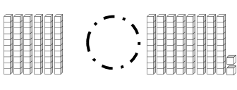
1.

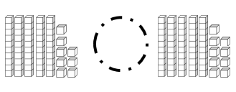
2.

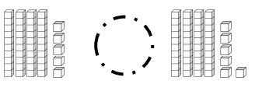
3.

4.

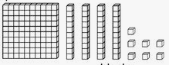
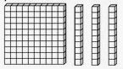

www.forrestmath.weebly.com

Comparing Numbers HW
TUESDAY
Stack and compare the following two and three digit numbers using the symbols: > < =

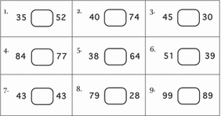

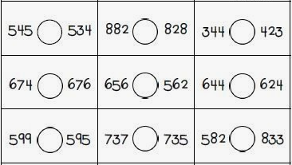

WEDNESDAY
Compare the following numbers by circling the correct set of words: greater than, less than, or equal to.
1. 57 is greater than – less than – equal to 570

2. 182 is greater than – less than – equal to 181

3. 65 is greater than – less than – equal to 56

4. 999 is greater than – less than – equal to 99

5. 747 is greater than – less than – equal to 747

Complete the following:

6. Write down three numbers that are greater than 82

_______ ________ ________

7. Write down three numbers that are less than 379

_______ ________ ________

8. Write down one number that is equal to 933

________

Put the following models in order from greatest to least

ppppd ]pr ppppi

______ _______ _______
THURSDAY
Complete the following test formatted questions by comparing or ordering.
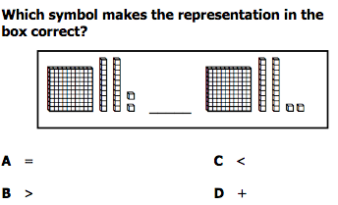
1.

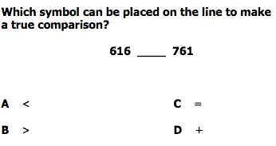
2.

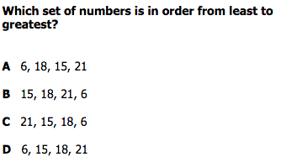
3.

