**Name _________________________________**

**MONDAY**

**Part I: Use the models below to compare the following fractions using the symbols (> < =)**

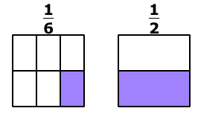

1)

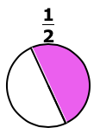

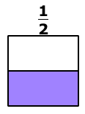

2)

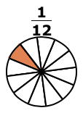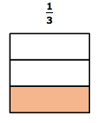

3)

**Part II: Do the following equations show equality?**

4) 56 – 12 = 44 5) 20 = 15 + 5

6) 72 = 90 – 12 7) 88 – 59 = 12

[www.forrestmath.weebly.com](http://www.forrestmath.weebly.com)

**Comparing Fractions HW**

**TUESDAY**

**Part I: Shade the models below and then compare using the symbols (> < =)**

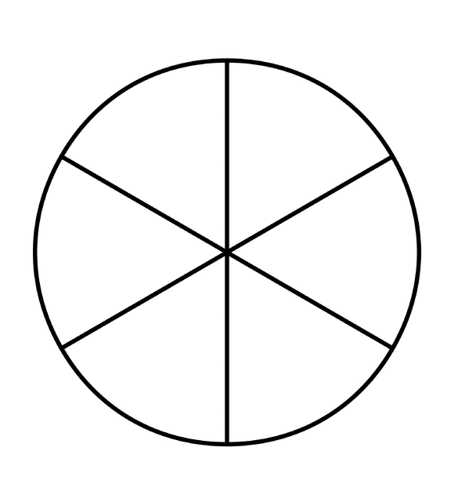

1) 3^ 5^

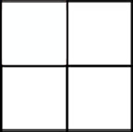

2) 3$  1$

3) 2*   5*

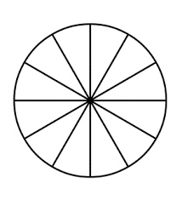

4) 9! @ 7! @

**Part II: Solve the following word problem.**

Over the summer Sarah collected 57 seashells when she visited Buckroe Beach with her family. Emily collected 83 seashells over the summer when she visited Virginia Beach with her family. About how many more seashells did Emily collect than Sarah?

_________ seashells

**WEDNESDAY**

**Part I: compare the following fractions in word form.**

1) 1@ > 1$

* One-two is greater than one-four
* One-half is greater than one-fourth
* One-half is less than one-fourth

2) 1* < 1#

* One-eighth is less than one-third
* One-eighth is greater than one-third
* One-eight is less than one-three

3) 5! @ = 5! @

* Twelve-fifths is equal to five-twelfths
* Five-twelfths is equal to five-twelfths
* fifth-twelve is equal to fifth-twelve

**Part II: Shade the fraction models**

4) How many hearts do you need to shade to show six-eights?



5) How many stars do you need to shade to show two-sixths?

6) How many happy faces do you need to shade to show one whole or four-fourths?

**THURSDAY**

**Part I: Which of the following makes the statement true?**

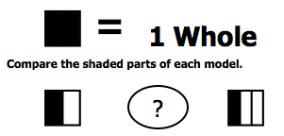

1)

A) > B) < C) = D) +

2) 1% ? 1^

A)  >  B)  = 

C)  <  D) + 

**Part II: What fractions of the shapes are NOT shaded?**





 