Name _________________________________
MONDAY
Part I: Identify the parts of the calendar

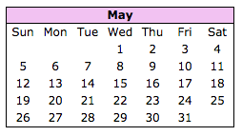
1. Circle the month
2. Put a rectangle around the days of the week
3. Lightly shade the dates

Part II: Use the calendar above to identify specific days and dates.

4. What date is the 3rd Monday in May? _________

5. How many Fridays are there in May? ________

6. How many days are in the Month of May? ________

7. Memorial Day is May 27th. What day of the week is May 27th? _______

8. What date is the second Sunday in May? ______

9. The 4th Friday in May is an early release day. What date is The 4th Friday in May? ___________

Calendar HW
TUESDAY
Part I: Answer the following calendar related questions.

1. How many months are in 1 year? ______

2. List the names of the months: ______________, ______________, ______________, ______________, ______________, ______________, ______________, ______________, ______________, ______________, ______________, ______________.

3. How many days are in 1 week? ________

4. List the days of the week: ______________, ______________, ______________, ______________, ______________, ______________, ______________

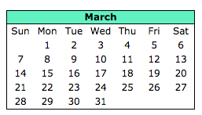
Part II: Using the calendar below, answer the following questions.

5. St. Patrick’s Day is on Wednesday, March 17th. What is the date exactly one week after St. Patrick’s Day? _____________

6. What day will it be four days before March 30th? __________

www.forrestmath.weebly.com
WEDNESDAY
Part I: Use the calendar below to answer the following questions.
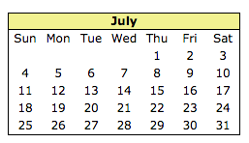

1. July 4th is a holiday. What is two weeks after July 4th?
_____________

2. How may Wednesdays are there in July? ________________

3. What day of the week is July 23rd? ________________

4. Avery’s birthday is on July 27th. She sent out invitations ten days before her birthday. When did Avery send out invitations to her birthday? ______________________

5. The Eskew’s have planned their family vacation. They are leaving for their trip on Friday, July 9th. They will return in eight days. What day will they return? _________________________

6. Wyatt mows lawns for extra money every Saturday morning. How many days will he mow lawns in July? ________________

7. Serenity’s family goes out to breakfast every Sunday morning. This month they missed going one Sunday. How many times did they go out to breakfast in July? _________________

www.forrestmath.weebly.com
THURSDAY
Part I: Use the calendar below to answer the following questions.
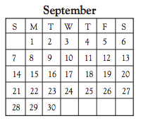
1. What day of the week is the first day of the month? ___________

2. What date is the last day of the month?
___________

3. What is the date of the 3rd Saturday of the month? ____________
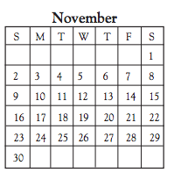

4. Harper’s birthday is on November 24th. What day of the week is November 24th?
___________

5. Thanksgiving is on the last Thursday in November. What date is Thanksgiving according to this calendar?
____________

6. Thanksgiving break lasts for 5 days total. If the last day of Thanksgiving break is Sunday, November 30th, what is the first day of Thanksgiving break?
_________________

7. There are 30 days in November, how many full weeks are in November? ___________

