Name _________________________________
MONDAY
Part I: Use the place value blocks below to complete each addition problem. Write the addition fact below

Ex. j + y = jy
7 + 6 = 13

1. p + p =

2. B + c =

3. l + x =

4. n + m =

5. d + v+ p =

www.forrestmath.weebly.com
Basic Addition HW
TUESDAY
Part I: Solve the following

1. If I double the number 7, the sum will be ________

2. What is three more than eight? _______

3. What is five less than 16? ______

4. The sum is: ________________________________________

5. The difference is: ___________________________________

Part II: Answer each addition problem. Draw place value blocks if needed.

3) 13 + 6 = 4) 3 + 9 = 5) 7 + 7 =

6) 12 7) 4 8) 18 9) 15
+ 6 + 4 + 2 + 3

Part III: Solve the following addition word problems.

10) This weekend I visited the Norfolk Zoo and saw 8 sea lions and 10 flamingos. How many animals did I see?

11) In my class there are 9 girls, 9 boys, and 1 teacher. How many people are in my class?

WEDNESDAY
Part I: Define

What is a related fact? _________________________________
____________________________________________________

Part II: Write four different related facts using the numbers given.
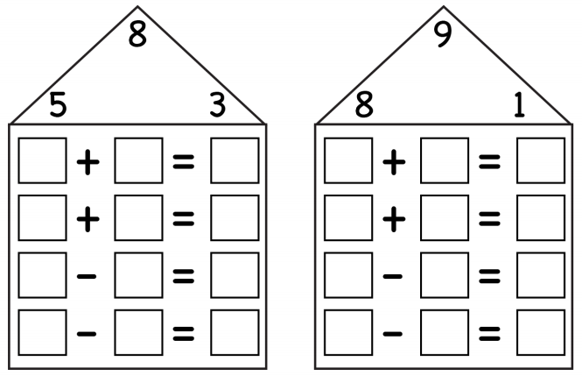
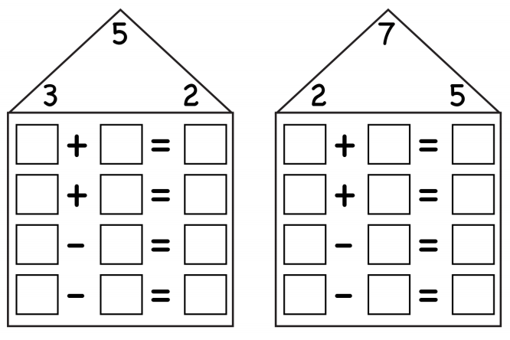

Test Practice Thursday

THURSDAY
Part I: Basic addition test practice
1. What number makes this statement TRUE? 9 – ? = 7

A) 2 B) 3 C) 7 D) 16

2. Which number can be placed on the line to make the number sentence TRUE?
4 + ___ = 12

A) 4 B) 6 C) 7 D) 8

3. Which of the following could be solved using this numerical sentence?
16 + 9 = _____

A) Don has 16 small cars. His father gave 9 to his brother. How many cars does Don have now?

B) Don sold 9 of his 16 cars. How many does he have left?

C) Don’s brother has 16 cars. Don has 9 cars. How many cars do Don and his brother have altogether?

D) Don’s uncle gave him 9 cars for his birthday. Don’s dad gave him 6 cars for mowing the lawn. How many cars does Don have altogether?

Part II: Related facts test practice

4. Which fact is a related fact to 8 – 1 = 7?

A) 7 + 2 = 9 C) 9 – 7 = 2

B) 1 + 8 = 9 D) 1 + 7 = 8

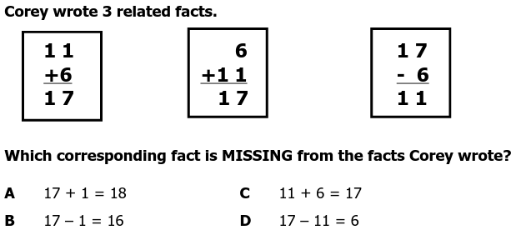
5. xs

