Name _________________________________
MONDAY
Part I: Fill in the chart below
Picture | Name | Number of Sides | Number of angles

Part II: Write either true (T) or false (F) on the line beside each statement.

1. _____ A square can also be classified as a rectangle.
2. _____ A rectangle can also be classified as a square.
3. _____ A square can also be classified as a rhombus.
4. _____ All points on a circle are equidistance from the center.
5. _____ Opposite sides of a rectangle are perpendicular.

www.forrestmath.weebly.com
SOL Review HW #2
TUESDAY
Part I: Write the name of the shape being described.
1. I have four equal sides and four right angles _____________
2. My opposite sides are parallel and congruent. I also have four right angles. ______________________
3. I have three sides and three angles ___________________
4. I have four congruent sides and may or may not have right angles ________________________
5. I am any shape that has four sides ____________________
6. I have seven sides ______________________

Part II: Name the shapes that combine to make the figures below.

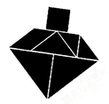 ______________________________ ______________________________

______________________________
______________________________

______________________________
______________________________
WEDNESDAY
Part I: How do you find the following.

1. Perimeter of a polygon - _____________________________

2. Area of a polygon - _________________________________

3. Area of a right triangle - _____________________________

4. Volume of an object - _______________________________

Part II: Find the area of the following polygons.

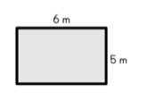
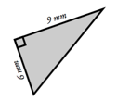
5. 6.

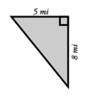
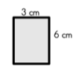
7. 8.

9.

Test Practice
THURSDAY
