Name _____________________________________
TUESDAY
Part I: Use the probability vocabulary words from part I, and the spinners below, to answer the following questions.
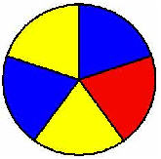

Yellow Blue

Blue Red

Yellow

1) What is the likelihood that the spinner will land on RED? ________
What fraction of the spinner is RED? _________________

2) What is the likelihood that the spinner will land on BLUE? ______
What fraction of the spinner is BLUE? _________________

3) What is the likelihood that the spinner will land on YELLOW? What fraction of the spinner is YELLOW? ___________________

PART II: Would it be fair if I was playing a game with my friend and we had different spinners like the ones shown below? Why or why not? Explain below.
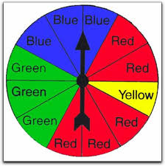
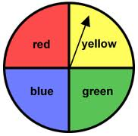

Player 1’s spinner Player 2’s spinner
____________________________________________________________________________
Probability HW
WEDNESDAY
____________________________________________________________________________________________________________
________________________________________________________________________________________________________________________________________________________________________________________________________________________

Part I: Use fractions to show probability.
If the following marbles were in a baggie and you pulled one out without looking, what is
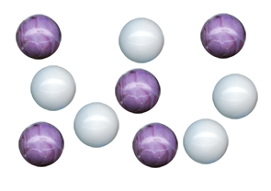
the probability that you would
pull out:

a) light marble = _________________

b) dark marble = _________________

c) a striped marble = ______________

d) a round marble = _______________

Please place the fractions on the number line
(hint: place 0 and 1 first!)

Part II: Review

Which product would be in the 200 to 300 range?

A) 9 x 16 B) 17 x 11

C) 15 x 12 D) 19 x 13

Mr. Lang planted 35 rows of corn. There are 15 corn plants in each row. How many corn plants is that in all?
_______________

www.forrestmath.weebly.com
THURSDAY
PART I: Fill in the table and then create a tree diagram showing all
possible combinations for the following situation.

Anne is deciding what to order at the ice cream shop. She can choose a plain cone, waffle cone, or sugar cone, and she can have cookie dough, strawberry, or chocolate ice cream. She can have raspberry, butterscotch, cherry, or caramel sauce. How many different combinations can Anne order?

Cones | Ice Cream Flavors | Toppings

Part II: Create a tree diagram showing all of the possible combinations.

Part III: What multiplication problem could you use to find out all of
the possible combinations? _________________________________

www.forrestmath.weebly.com

Part II: Create a tree diagram using the information below and then match it to the correct answer choice.

Morgan is getting dressed for a party. She must choose 1 pair of shoes, one pair of socks and 1 belt. Based on the information in the chart, which tree diagram shows
all of Morgan’s possible combinations?

Color of Shoes | Color of Socks | Type of Belt
Black | Red  White | Leather  Canvas

