Name _________________________________
MONDAY
Part I: Fill in the chart below.

Number | Factors | Prime or Composite?
1.
4

2.
11

3.
16

4.
23

Part II: Circle all of the lists that contain one prime
number and two composite numbers?

1, 33, 45 2, 45, 77 7, 45, 77

7, 33, 45 2, 13, 33 1, 13, 33

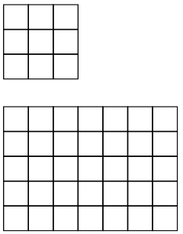
Part III: Circle each of the following arrays that represent a composite number.

Prime/Composite HW
TUESDAY
Determine if the following numbers are prime or composite by practicing the factor tree strategy.

Example:
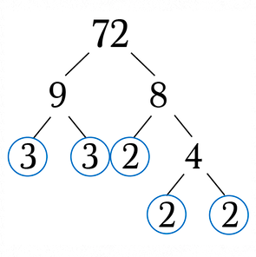
The number 72 is composite.

1) 28 2) 55

3) 43 4) 81

WEDNESDAY
Determine if the following numbers are prime or composite by practicing the factor rainbow strategy.

Example:
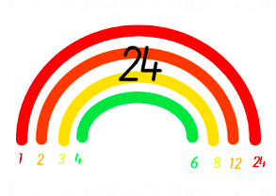
The number 24 is composite.

1) 23 2) 45

3) 66 4) 36

www.forrestmath.weebly.com

THURSDAY
Part IV: Test Practice

1. Which of the following list contains only odd numbers?

F) 2, 13, 25, and 53 G) 11, 23, 33, and 48

H) 3, 15, 21, and 39 J) 7, 9, 24, and 41

2. Which number is a composite number between 15 and 30?

A) 17 B) 21 C) 29 D) 32

3. Which of the following statements best explains why 14 is an even number?

F) All even numbers have only two factors

G) All even numbers are not divisible by 2

H) All even numbers have more than two factors

J) All even numbers are divisible by 2

4. Which of the following statements best explains why 3 is a prime number?
A) All odd numbers are prime numbers
B) All even numbers are composite numbers
C) All prime numbers have exactly two factors
D) All prime numbers have more than two factors

