Name ______________________________________
MONDAY
Directions: Solve each of the following using the order of operations.
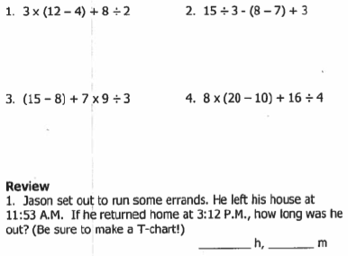
Review: Solve the following word problem
Ms. Thomas hired five people to do work around her house. She had to make sure that she paid them equally. When they were finished, she let them split $734. How much did each worker earn?
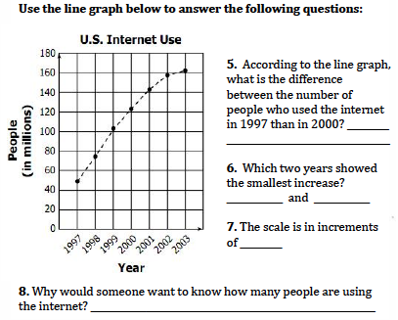

Order of Operations HW
TUESDAY
Directions: Solve each of the following
1) 3 ÷ 1 + 6 x 1 2) 8 ÷ 2 - 4 + 1

3) (8 – 6) ÷ (7 ÷ 7) 4) 3 + 1 x 8 ÷ 4

Review: Solve the following word problem.
Every month the cashier at the grocery store earns $2,156. How much does she earn in one year?

Each month the cashier earns $2,156 but she has to pay $850 for rent, $125 for food, and $431 in household bills. After paying for expenses, how much does she have left?

WEDNESDAY
Directions: What is the first step when solving using the order of operations?

1) 8 - 1 x (8 - 2) 2) (10 + 10) 5 + 8 – (4 + 3)

Directions: Which shows the correct way to solve using the order of operations?

(8 – 2) ÷ 6 x (9 – 4) ÷ 5

a) (8 – 2) ÷ 6 x (9 – 4) ÷ 5 b) (8 – 2) ÷ 6 x (9 – 4) ÷ 5
6 ÷ 6 x 5 ÷ 5 6 ÷ 6 x 5 ÷ 5
6 ÷ 30 ÷ 5 1 x 5 ÷ 5
5 ÷ 5 5 ÷ 5
1 1

Review: Solve the following word problem.

Terry wanted to share some of the berries she grew this summer with her neighbors.

- On Monday Terry picked 12 baskets of berries.
- Tuesday she picked 13 baskets and on Wednesday she picked 11 baskets of berries
- Thursday she shared all of the baskets of berries she picked with her 9 neighbors.

How many baskets of berries did Terry give to each of her neighbors if they received the same number of baskets?

THURSDAY – Test practice

1. Using the order of operations, which calculation should be done first to simplify this expression?

31 + 17 × (10 + 26) ÷ 3

A) 17 × 10 B) 26 ÷ 3 C) 31 + 17 D) 10 + 26

2. What is the value of this numerical expression?

42 ÷ 6 × (5 + 3)

A) 56 B) 43 C) 33 D) 14

3. Which numerical expression has a value of 16?

A) 28 + 4 × (5 - 3) ÷ 4 B) 48 - 2 × 8 × 2

C) 56 + 24 ÷ 8 + 6 D) 59 + (7 – 2) × 4

4. Simplify this expression by showing a step – by – step process using the order of operations. Use the space provided.

54 + 6 × (3 + 6) ÷ 3

www.forrestmath.weebly.com

