Name _________________________________
MONDAY
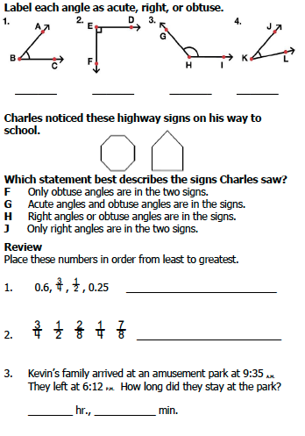
www.forrestmath.weebly.com
Angles/Triangles HW
TUESDAY
Part I: Complete the following definitions by using vocabulary words from the word bank.
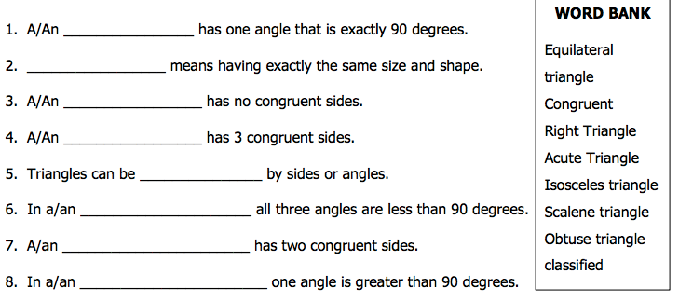

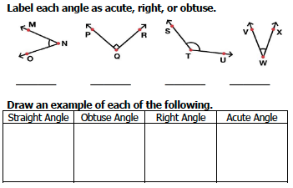
Review
Ashley visited Brianna at her home for 5 hours 36 minutes.
Is Ashley arrived at Brianna’s at 10:53 A.M., at what time did she
leave?
________ hr., ___________ min.

WEDNESDAY
Part I: Describe the following triangles.

1) obtuse triangle - ____________________________________

2) scalene triangle - ___________________________________

3) equilateral triangle - _________________________________

4) acute triangle - _____________________________________

5) isosceles triangle - __________________________________

6) right triangle - _____________________________________

Part II: name the following triangles using their sides (equilateral, scalene, isosceles)
7) 8)

__________________ ___________________
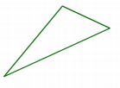
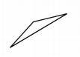
9) 10)

__________________ ____________________
THURSDAY
Part I: name the following triangles using their angles (obtuse, acute, right)
1) 2)

_________________ __________________

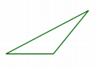
3) 4)

___________________ ____________________

