Name ____________________________ MMMR and Line Graph HW
TUESDAY
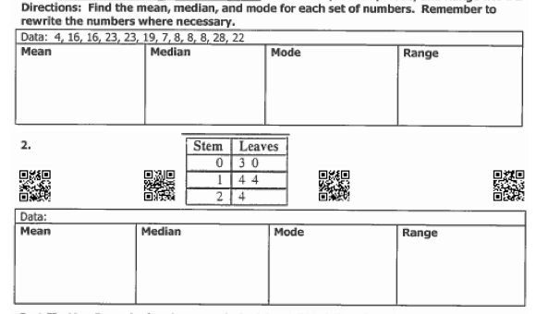

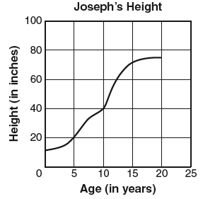
Part II: Use the line graph to answer the questions.
The line graph shows how Joseph’s height changed.
1. How tall was Joseph when he was 15 years old? ______

2. How many inches did Joseph grow between five and

ten years of age? _________

3. During which five year period did Joseph grow the:

most? __________________ least? __________________

www.forrestmath.weebly.com
WEDNESDAY
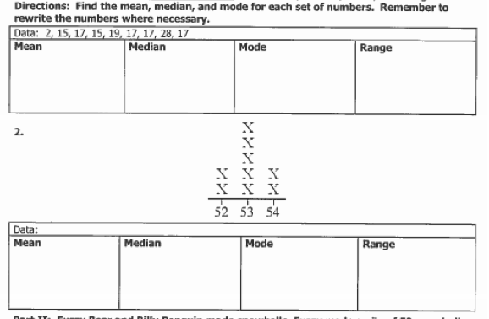

Part II: Use the graph below to answer questions 1-6.

The line graph below shows the number of people living in Newtown between 1900 and 2000. Use the graph to answer the questions.
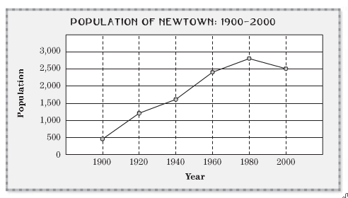
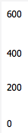
1. What was the population of Newtown in 1920? _____________________________

2. What was the population in 1960? _____________________________

3. In which 20-year period did the size of the population change the most? _____________________________

4. Did the population increase or decrease between 1900 and 1940? ____________________
5. How much did the population increase from 1920 to 1940? _________________________
6. Describe the change in population from 1980 and 2000. ____________________________
THURSDAY
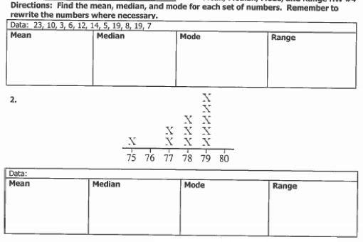

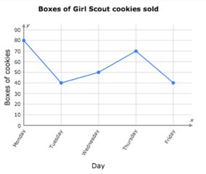

3. Did the number of cookies sold increase or decrease between Tuesday and Thursday? _________

4. What is the best day to sell Girl Scout cookies? ______________________

5. How many boxes of Girl Scout cookies were sold this week? ________

