Name _____________________________
WEDNESDAY

Part I: covert the following fractions into decimals by using division. See example for help.

1. 5! ) 2. 4^ 3. 7(

example
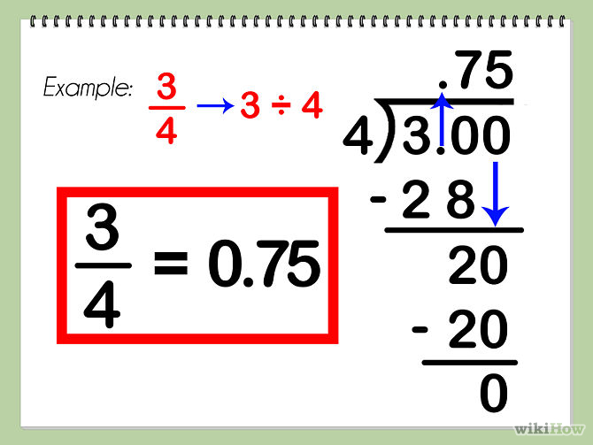

Review
Zach saved $19 in March. He saved $42 in April and $41 in May. Then Zach spent $82 on a keyboard. How much money does Zach have left?
Step 1 | Step 2 | Step 3

Look at the number line drawn below. What is the decimal value of A?

A
| | | | | |
0 1
A 0.80 B 0.60 C 0.40 D 0.20

www.forrestmath.weebly.com
Fraction/Decimal Equivalence
THURSDAY

Part I: Convert the following fractions to decimals

1. 3% 2. 4! @ 3. 6*

Review
1. On a Friday evening a pizza shop had orders for 4 pepperoni, 97 vegetable, and 335 cheese pizzas. If the 4 cooks each made an equal number of pizzas, how many pizzas did each cook make? (2 steps!)

Round each of the following decimals to the nearest tenth.
1. 2.36 _______ 2. 45.19 ______ 3. 5.321 ______

Round each of the following to the nearest whole number.

4. 23.14 _______ 5. 3.962 ______ 6. 68.49 ______

Solve
7. What is the product of 7 and 4.38?

