**Name _________________________________**

**TUESDAY**

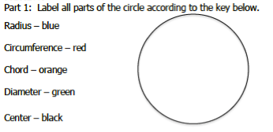

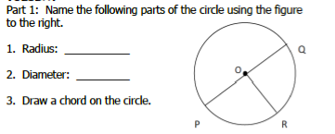

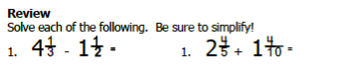

[www.forrestmath.weebly.com](http://www.forrestmath.weebly.com)

**Circles HW**

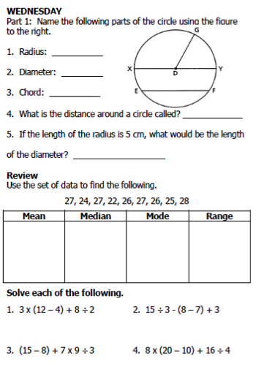

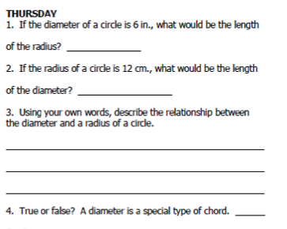

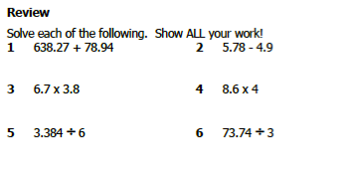

**Open Work Space**