**Name ________________________________________________________**

**TUESDAY**

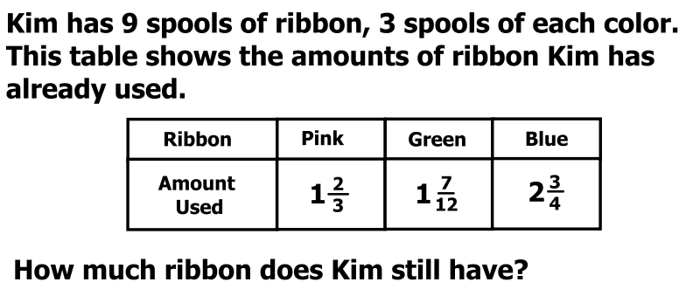

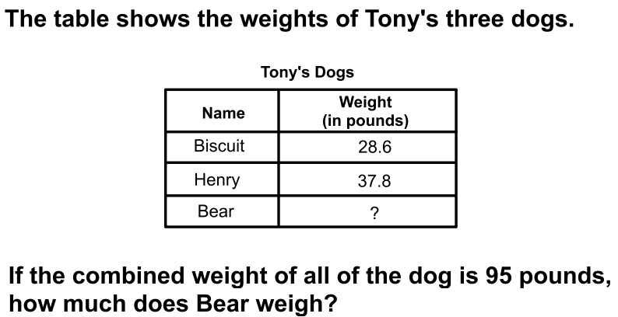

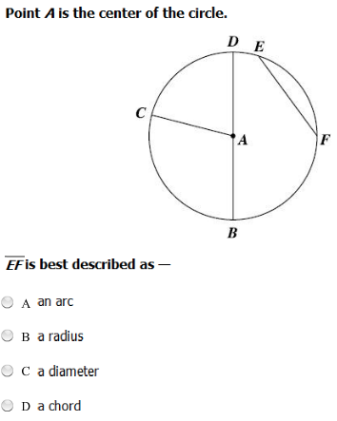

**Unit 9 Review HW**

**WEDNESDAY**

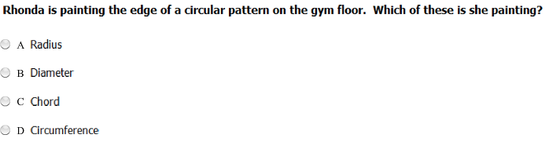



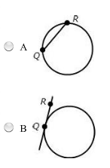 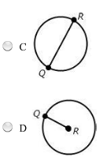

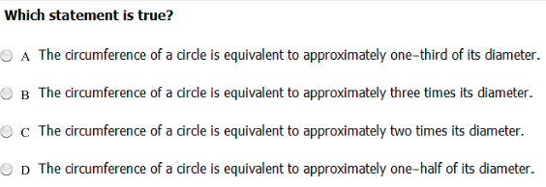

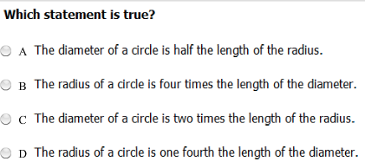

**THURSDAY**



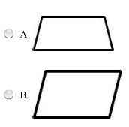 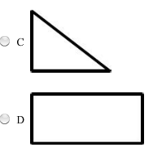

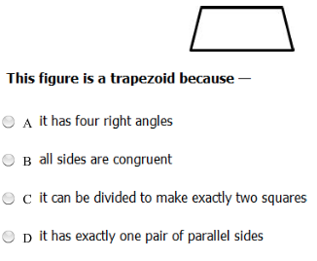

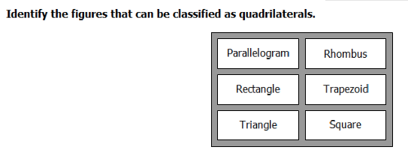

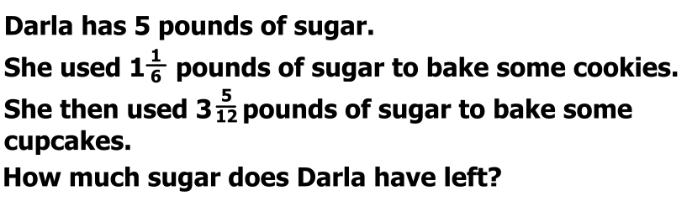

**THURS**

