Name ________________________________
MONDAY
Area, perimeter, volume review.

1. Explain how you find the volume of a rectangular prism or cube: _______________________________

2. Explain how you find the perimeter of an object:
___________________

3. Explain how you find the area of a right triangle:
___________________

4. Explain how you find the area of a rectangle or square:
___________________

Calculate the following

5. What would the area of a right triangle with the sides measuring 12 cm. and 20 cm. be? _____________

6. Find the perimeter of a square with the length of 13 in. and width of 16 in. _____________

7. Ms. Porter covered her bulletin board with pink paper. The area that she covered was a total of 120 inches². What could have been the measurements of her bulletin board?

A) 40 in. by 30 in. B) 40 in. by 3 in.
C) 60 in. by 60 in. D) 30 in. by 400 in.

8. What is the volume of a suitcase with the measurements
12 in. x 12 in. x 7 in.?

www.forrestmath.weebly.com

APV Review/Length Measurement HW
TUESDAY
Review
1. Mrs. Johnson ordered 10 pizzas for her son’s birthday party. The kids at the party ate $4\frac{7}{8}$ pizzas and the adults had $3\frac{1}{2}$of the pizza. How much pizza did Mrs. Johnson have left?

2. The fifth grade is going on a field trip. Lunches are being prepared by the school for each student. Below are the number of students in each class.
Porter | 25 students
Lavoie | 26 students
Gilchrist | 23 students
Thomas

If there were a total of 98 lunches prepared, how many students were in Ms. Thomas’s class?

__________ students

3. The field trip is to the Air and Space center to tour the museum and see an Imax movie.

- The admission cost is $11 per person.
- The Imax movie cost $6 per person.
- There are a total of 110 people going on the field trip.

What is the combined cost of the museum admission and the Imax movie for the group?

$__________

WEDNESDAY
It’s the 100th day of school! Celebrate by following the directions below:

1. How many ways can you make 100? Use addition, subtraction, multiplication, and division to create problems with answers that equal 100. They must be more than one step.
________________ _________________
________________ _________________
________________ _________________
________________ _________________
________________ _________________

2. How many hours are there in 100 days? ___________

3. How many weeks are there in 100 days? ___________

4. Judy took a $100 to the mall to go shopping. She was trying to decide what she wanted to buy so she made the list below. What could Judy buy with $100?

Jeans | $25.99
Summer Dress | $36.57
Boots | $49.99
Tennis Shoes | $29.33
Necklace | $19.99

How much of the $100 did she spend? _____________

How much of the $100 does she have left? _____________

THURSDAY
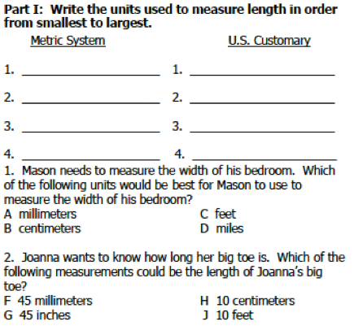
Part II: Complete the following conversion tables.
