Name ________________________
MONDAY

Part I: Find the Least Common Multiple (LCM) for the following numbers.
1) 3 and 5

3
5

2) 2 and 8

2
8

3) 4 and 7

4
7
Part II: Change the following fractions into mixed numbers.

4) 7$ 5) 9% 6) 1 3* 7) 1 1&

Part III: Review

8) 54.92 + 1.356

9) 238.4 - 32.77

www.forrestmath.weebly.com
Adding Fractions HW
TUESDAY

Part I: Change the following fractions into mixed numbers

6$ 7% 1 0( 1 4*

Part II: Find the Greatest Common Factor (GCF)

4) 6 and 8
6 | 1 x 6
8 | 1 x 8

5) 3 and 4
3 | 1 x 3
4 | 1 x 4

Part III: Review

6) 54.7 x 3.9

7) 36.1 ÷ 7

Circle the fraction/decimals that are equivalent

0.39 = 1# 3$ = .75 0.5 = 6! @

WEDNESDAY
Part I: Simplify the following fractions using Greatest Common Factor (GCF)

3! @ 6( 4! ) 2^

Part II: Add the following fractions.
1@ + 3*
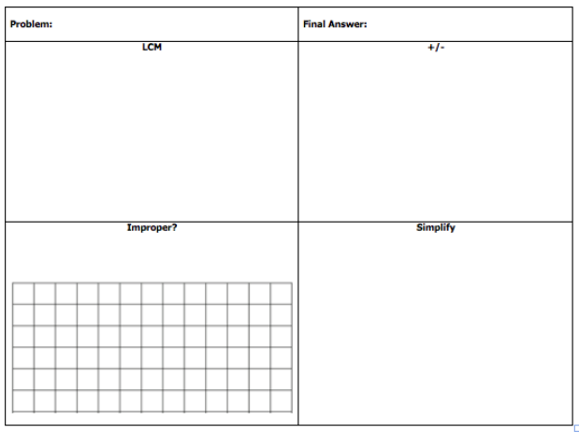

Part III: Review

32 f8372 14 f 926

www.forrestmath.weebly.com
THURSDAY
Part II: Add the Following Fractions using the four-square chart provided.
2$ + 4&

Part II: Review

The Girls on the Run team ran their 5k last Saturday. Each girl ran 3.1 miles. If twenty girls ran the race, how many miles did they run as a team?

How would your product change if you included the miles that the four coaches ran?

