Name ______________________________________
MONDAY

Use the organizer to solve the following problem.

1. Zach saved $190 in March. He saved $42 in April and $141 in May. Then Zach spent $82 on a keyboard. How much money does Zach have left?

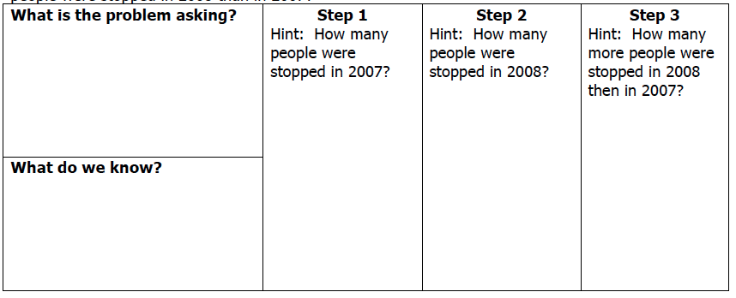
2. In this problem, the verb saved means to: add or subtract

3. In this problem, the verb spent means to: add or subtract

Solve
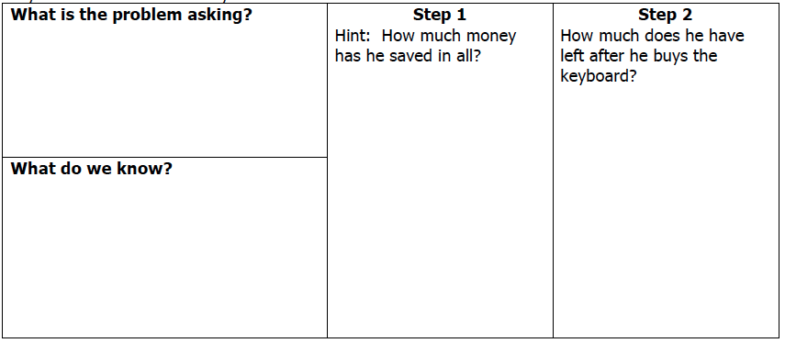

4. The fourth grade girl scouts have a goal of selling 3,658 boxes of cookies in 4 months. They sold 535 boxes the first month, 492 boxes the second month and 984 boxes the third month. How many more boxes do they need to sell to reach their goal?

+/- Word Problem HW
TUESDAY

Use the organizer to solve the following problem.

1. One troll stopped 53,570 people from crossing a bridge in 2007. He then stopped 52,980 people in 2008. A second troll stopped 200,101 people in 2007 and 201,600 people in 2008. How many more people were stopped in 2008 than in 2007?

REVIEW – Facts and Rounding

2) 12 x 3 = ________ 2) 11 x 11 = ________ 3) 6 x 7 = _________

4) 8 x 9 = _______ 5) 42 ÷ 6 = ________ 6) 72 ÷ 9 = ________

Circle all of the following numbers that would round to 700,000

734,998 749,110 651,003

622,967 699,707 813,813

www.forrestmath.weebly.com
WEDNESDAY

Use the organizer to solve the following problem.

1. Jamila wants to see all 1,200 paintings in the museum. She saw 616 of them on Monday. On Tuesday, she saw 389 paintings. How many paintings does Jamila still need to see?
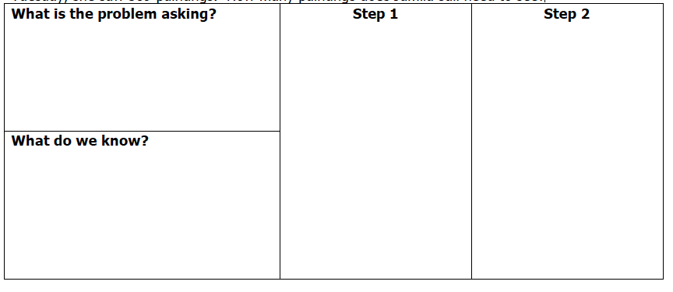

REVIEW – Adding/Subtracting with Estimation

2) Khyri was playing his favorite video game. On Monday he scored 17,689 points, on Tuesday he scored 54,721 points, and on Friday he scored 8,221 points. About how many points did he score this week?

 | Actual Answer | Estimated Answer
Combine 63,890 and 46,946.
What is the difference between 506,789 and 34,388?
THURSDAY

Solve the following problems.

1. I received $3,492 in my paycheck. After I pay $1,875 for my house and $552 for my car, do I have enough money to go on a weekend getaway that costs $925?

2. In this problem, what does the verb received mean?

ADD SUBTRACT

3. In this problem, what does the verb pay mean?

ADD SUBTRACT

4. The students are raising money for Pasta for Pennies. The 4th grade raised $57.86 the 3rd grade raised $46.37. The 5th grade raised $12 more than 3rd and 4th grade combined. How much did 5th grade raise?

5. Mrs. Peters is going to drive to Minneapolis for a Vikings game. It is 1,000 miles to Minneapolis, Minnesota from Hampton, Virginia. She plans to spend three days driving. She will stop after 256 miles at her aunt’s house. The second day she will drive 342 miles to visit her sister. How many miles will she need to drive the third day?

www.forrestmath.weebly.com

