Name _________________________________
MONDAY – Elapsed Time Review

1) Tarrant Elementary dismisses students at 3:45pm. If school lasts for seven hours and twenty-five minutes, what time does school start?

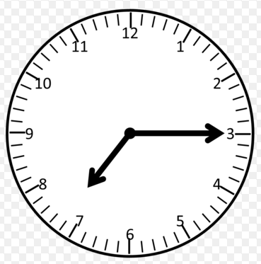
2) Kaleb and his family went on a road trip. They left their house at the time shown on the clock. If they decided to stop for lunch after driving for 8 hours and 15 minutes, what time did they stop for lunch?

3) There was a Harry Potter movie marathon on TV last weekend. The marathon started at half past nine in the morning and didn’t end until quarter to twelve at night. How long was the Harry Potter movie marathon?

www.forrestmath.weebly.com
SOL Review HW #3
TUESDAY – Irregular Polygon Review
Part I: Name the following polygons

___________ __________ __________ ___________

Part II: Create the following polygons using the geoboard provided: trapezoid, rhombus, parallelogram

WEDNESDAY – Patterns Review
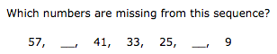
1.

2. Which numbers are missing from this sequence?

26, ______, 20, 17, _______, 11, 8

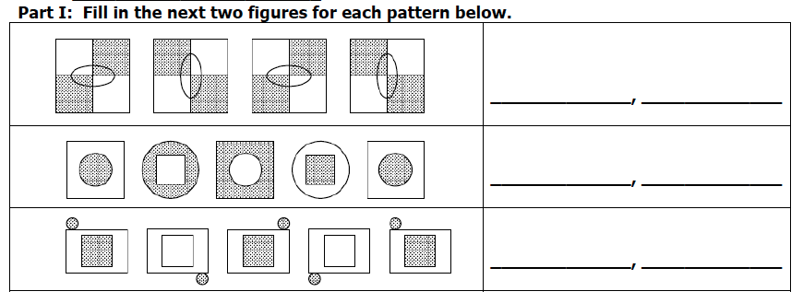

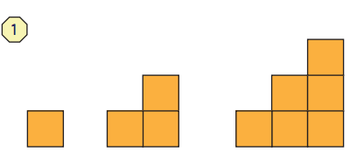
4.

________________________

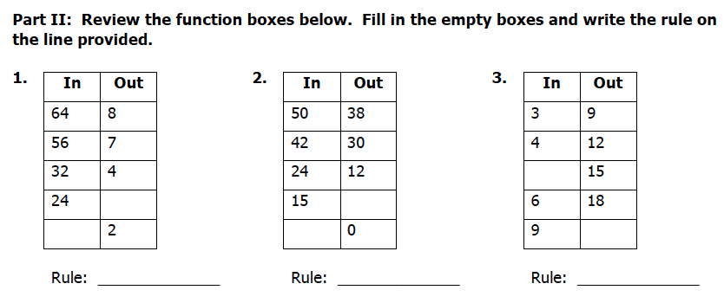

THURSDAY – Test Practice

1. Mark’s class went on a field trip. They left school and arrived at the park at 9:05. They rode the bus for one and a half hours. What time did Mark’s class leave school?

A) 8:35 a.m. B) 7:35 a.m.

C) 8:05 a.m. D) 7:05 a.m.

2. Look for the pattern in the sequence of numbers below.
16, 22, 19, 25, 22, 28

Which rule describes this pattern best?

A) add 3, subtract 6 B) add 6, subtract 3

C) add 16, subtract 6 D) add 9, subtract 6

3. Which statement is true about a polygon?

A) A polygon can have curved sides.
B) A polygon can be an open figure.
C) A polygon is a closed figure.
D) The line segments in a polygon can intersect.

4. What is the name of the figure shown below?




