Name _________________________________
MONDAY – Add/Subtract Decimals Review
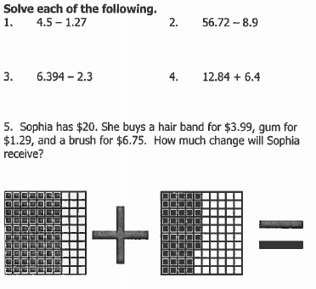
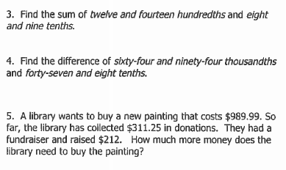

SOL Review HW #2
TUESDAY – Probability Review
2
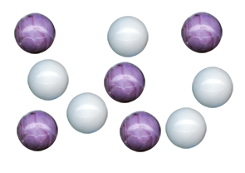
If the following marbles were in a baggie and you pulled one out without looking, what is the probability that you would pull out:

a) light marble = _________________

b) dark marble = _________________

c) a striped marble = ______________

d) a round marble = _______________

Please place the fractions on the number line (hint: place 0 and 1 first!)

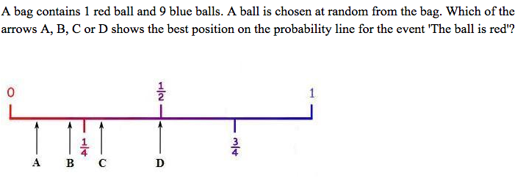

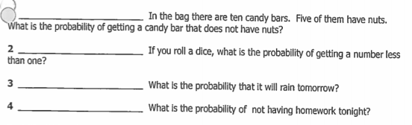

www.forrestmath.weebly.com
WEDNESDAY – Equivalent Measurements Review

1 foot = ____ inches 1 yard = ____ feet

1 cm = ____ mm 1 kg = _____ g

1 lb = ____ oz.

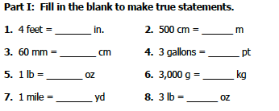

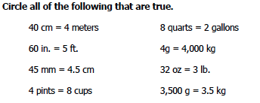

10. Zach had 64 ounces of soda. He poured 8 ounces into each
of 5 glasses. How much soda was left over?

www.forrestmath.weebly.com
Test Practice
THURSDAY
