Name ________________________________
MONDAY
1. Zach saved $1,938 in March. He saved $428 in April and $1,241 in May. Then Zach spent $1,982 on a plane ticket to Hawaii. How much money does Zach have left?

2. One troll stopped 53,570 people from crossing a bridge in 2007. He then stopped 52,980 people in 2008. A second troll stopped 200,101 people in 2007 and 201,600 people in 2008. How many more people were stopped in 2008 than in 2007?

3. I received $3,492 in my paycheck. After I pay $1,875 for my house and $552 for my car, do I have enough money to go on a weekend getaway that costs $925?

4. Khyri was playing his favorite video game. On Monday he scored 17,689 points, on Tuesday he scored 54,721 points, and on Friday he scored 8,221 points. About how many points did he score this week?

SOL Review HW #1
TUESDAY
Part I: Compare the following fractions
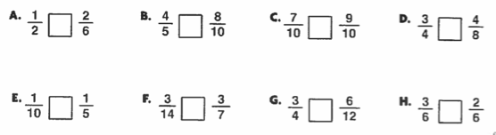

Part II: Order the following fractions
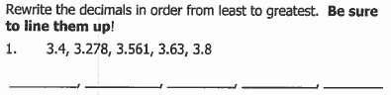

1@
2. Circle all of the fractions less than and draw a rectangle around all of the fractions greater than .
1@

7! @
33! )
5^
1$
3*

1@
3. Using as a benchmark, place the following fractions in order from least to greatest.
7! )
2*
4! @
3^

____________________________________________________
0 1

www.forrestmath.weebly.com

WEDNESDAY
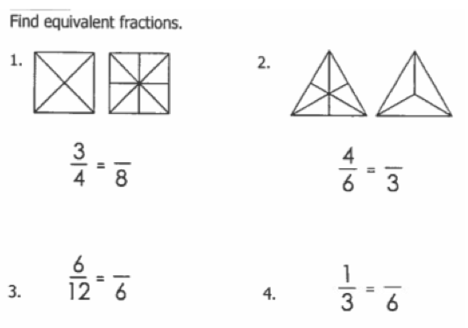
Part I:

Part II:

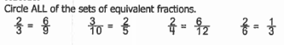

Part III: List at least 5 fractions that are equivalent to one-half.

______ ______ _______ _______ _______

www.forrestmath.weebly.com
Test Practice
THURSDAY
1. On Tuesday, Yesenia and her family drove 123 kilometers to her grandmother’s house. On Thursday they drove 180 kilometers to her godmother’s house. On Saturday, they drove 350 kilometers to go back home. About how many kilometers did they drive?

A 200 km B 400 km C 600 km D 700 km

2. Mr. Kaiser has 176 mints in the jar on his desk. If he divides the mints equally among eight of his students, how many mints will each student get?

A 21 mints B 22 mints C 23 mints D 26 mints

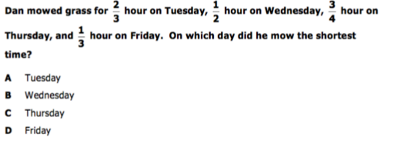
3.

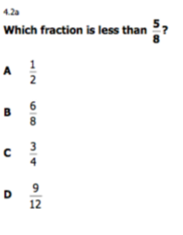
4.

