Name _________________________________
MONDAY – Third Grade Review
Part I: Write each of the following in standard form.

1. Forty two thousand, eleven _________________________

2. Three hundred five thousand, eight hundred seventy six

_____________________________

3. Six hundred twenty thousand, five hundred ten

_____________________________

4. Seven hundred fifty thousand, three hundred seventy

_____________________________

Part II: Identify the place value for each digit in the numbers below.
724,916 402,183
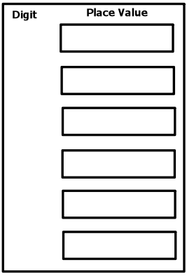

Place Value HW
TUESDAY
Part I: Label a place value chart. Be sure to include hundred thousands (HT), tens (T), thousands (TH), ones (O), millions (M), ten thousands (TT), hundreds (H), hundred millions (HM), and ten-millions (TM). Place the commas where they belong.

Part II: Label the place of each digit in the following numbers.

5 7 1, 9 0 2

3 8 2, 4 3 8, 0 0 3

6 7, 9 1 2

1, 3 3 6

5 7, 0 1 0, 3 6 8

6, 3 9 9, 1 4 6

www.forrestmath.weebly.com
WEDNESDAY

Part I: Write the following numbers in expanded form.

Ex) 546 | 500+40+6
2,671

1,358,002

40, 824

734,290

503,018, 334

Part II: Write the following standard form numbers in written form.

5) 38,944 ___________________________________________
________________________________________________________________________________________________________

6) 3,709,313 ________________________________________
________________________________________________________________________________________________________

7) 843,620 __________________________________________
________________________________________________________________________________________________________________________________________________________

8) 34,802,711 ________________________________________
________________________________________________________________________________________________________
THURSDAY
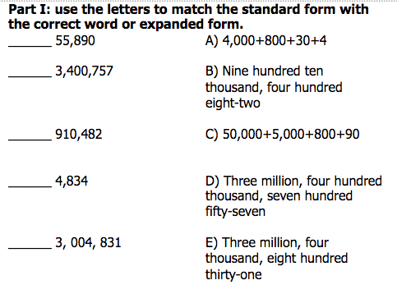
Part II: Write the place and value of the underlined digit.
 | Place | Value
Ex) 547 | Hundreds | 40
2,671
1,358, 002
83,092,456
734,290

40, 824

