Name ________________________________
MONDAY
Part I: Complete the multiplication chart below
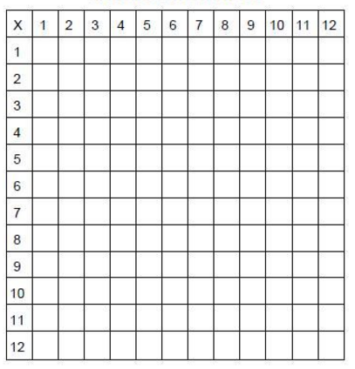

Part II: 3rd grade review

1) 6 2) 3 6 3) 7 4) 2 8
x 5 x 5 x 4 x 4

www.forrestmath.weebly.com
Multiplication HW
TUESDAY
Part I: Make a connection!
⁺¹
Ex. 6 4 6 0 4
x 3 x 3 x 3
192 180 + 12 = 192

64 x 3 = 192 is actually 60 x 3 + 4 x 3. Notice you calculate the same product! Try it!

1) 5 2
x 4

2) 7 1
x 5

Part II: Use rounding to fill in the chart below.

NUMBER | Nearest ten thousand | Nearest thousand | Nearest hundred
905,394

5,641,998

483,217

WEDNESDAY
Part I: Solve the Following

1. 7 2 2. 2 3 3. 9 3
x 5 8 x 8 9 x 5

Part II: Review the Following

4. 958,021 5. 445,002
+ 376,239 - 255,916

6. 21 ~ 3 = ______ 7. 54 ~ 6 = _____

Part III Preview: Fill in the empty boxes and write the rule on the line provided.

In | Out
63 | 9
49 | 7
35 | 5
21
 | 1
In | Out
50 | 38
42 | 30
24 | 12
15
 | 0
2. 3.

Rule: _____________ Rule: ______________

www.forrestmath.weebly.com
THURSDAY

1. What is the product of 28 and 57?

F) 1,496 G) 1,546 H) 1,596 J) 1,606

2. Look at the sets of factors below. Which product will be the largest? Explain.

97 x 19 45 x 8 39 x 10

____________________________________________________________________________________________________________________________________________________________

3. Estimate and find the product of 79 x 82.
Show your work!

4. 85
x 7 A) 92

B) 592

C) 595

D) 1,595

