Name ______________________________________
TUESDAY
Multiplication Strategy: Students need to know how to create a multiplication chart for use on assessments while they work on memorizing their multiplication facts 0-12.

Directions: complete the multiplication chart below.
Hint: start with the foundational facts first - 0, 1, 2, 5, 10
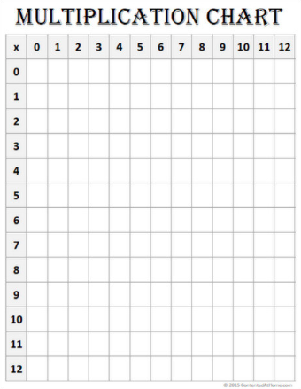

Basic Multiplication Facts HW
WEDNESDAY
Multiplication Strategy: Students need to know how to skip count, or count forward by various numbers while the work on memorizing their multiplication facts 0-12.

Directions: complete the skip counting tables by adding the number that you start with.

Example: add 2 to get the next number
2 | 4 | 6 | 8 | 10 | 12 | 14 | 16 | 18 | 20

3

4

5

6

7

8

9

10

11

12

Access Forrest’s math homework website at:
www.forrestmath.weebly.com
Updated weekly on Mondays.
THURSDAY
Directions: Time yourself! See how quickly you can answer the following basic multiplication facts. Try to solve them all in 1 minute or less!
