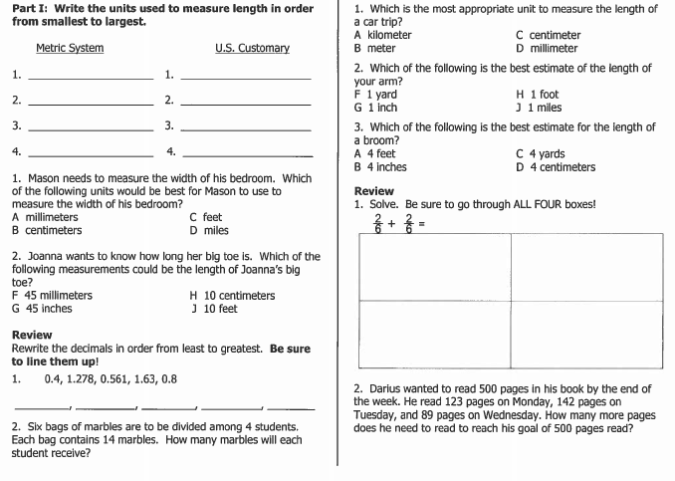

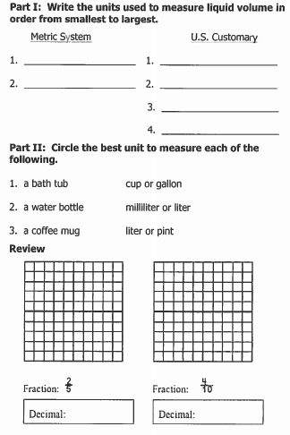

Part I: Draw the big “G” in the space provided below.

Part II: Use the big “G” to make the following conversions:

1. How many cups are in one gallon? ________

2. How many quarts are in a half-gallon? ________

3. How many pints are in three quarts? _________

4. How many quarts are in four gallons? __________

5. How many cups are in a half-gallon? __________

6. How many quarts does twenty cups make? _________

Part III: Review
