Name _________________________________
TUESDAY
In your own words, explain what the least common multiple (LCM) and how to find it: _______________
__________________________________________
__________________________________________
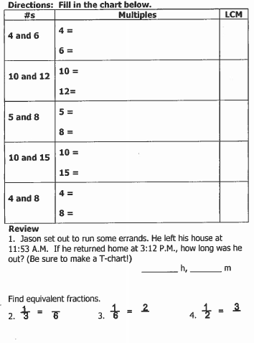

www.forrestmath.weebly.com
LCM and GCF HW
WEDNESDAY
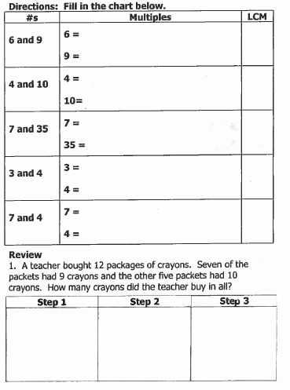

www.forrestmath.weebly.com
THURSDAY

In your own words, explain what greatest common factor (GCF) is and how to find it: __________________________________________
__________________________________________
__________________________________________

