**Name _____________________________**

**MONDAY**

**Part I: covert the following fractions into decimals.**

1. 5! ) 2. 3$ 3. 2%

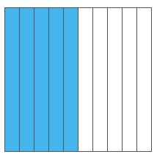 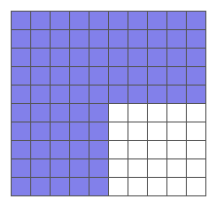 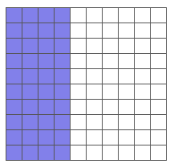

**_______ _______ ______**

**Review**

Zach saved $199 in March. He saved $342 in April and $410 in May. Then Zach spent $382 on a keyboard. How much money does Zach have left?

|  |  |  |
| --- | --- | --- |
| **Step 1** | **Step 2** | **Step 3** |
|  |  |  |

**Shade the figures to make equivalent fractions.**

2. l=r 3. l=e4. C=a 5. T=p

[www.forrestmath.weebly.com](http://www.forrestmath.weebly.com)

**Fraction/Decimal Equivalence**

**TUESDAY**

**Part I: Convert the following fractions to decimals**

1. 3% 2. 1@ 3. 2$ 4. 9! )

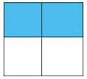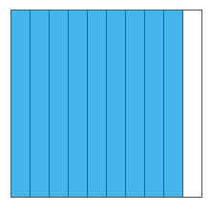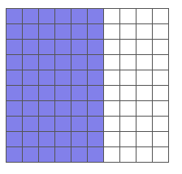 

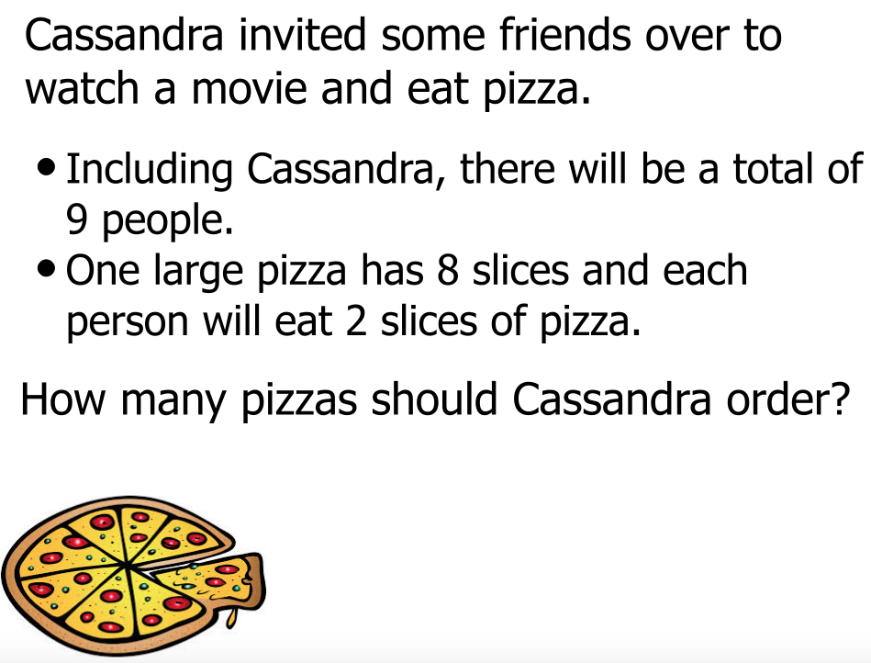 **_______ _______ _______ _______**

**Review**

**Round each of the following decimals to the nearest tenth.**

**1.** 2.36 _______ **2.**  45.19 ______ **3.** 5.321 ______

**Round each of the following to the nearest whole number.**

**4.** 23.14 _______ **5.** 3.962 ______ **6.** 68.49 ______

**Solve**

**7.** What is the difference between 54,827 and 25,736?

**WEDNESDAY**

**Part I: Change the fractions into decimals and shade the flats to compare using the symbols < > =**

1. 1% and 2! ) 2. 3$ and 4%

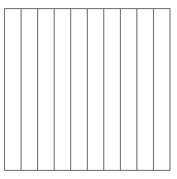  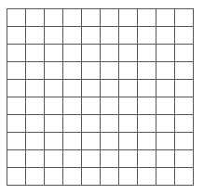 

________________________ ________________________

2. **Look at the number line drawn below. What is the decimal value of A?**

A

| | | | | |

0 1

**A** 0.80 **B** 0.60 **C** 0.40 **D** 0.20

3. **Karla ate  of her pizza. Which model shows  as a decimal?**

## **F** d **G** g **H** h **J** j

[www.forrestmath.weebly.com](http://www.forrestmath.weebly.com)

**THURSDAY**

1. **Paul needs  quart of oil in his car. Which of the following amounts is equivalent to  quart?**

**A** 0.25 quart **B** 0.50 quart

**C** 0.75 quart **D** 0.80 quart

2. 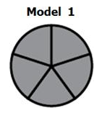 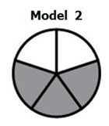

Model 1 represents one whole, what fraction/decimal does model 2 represent?

A) 0.6 and 3% B) 0.3 and 3%

C) 0.6 and 3! ) D) 0.3 and 3! )

3. **Numbers are written in pentagons A and B.**

**Which pentagon contains the greatest number?**

0.9 

A B

**Explain your answer.**