Name _________________________________
MONDAY
Solve the following.
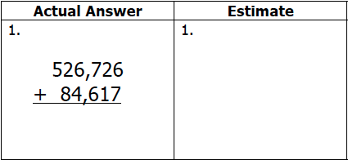
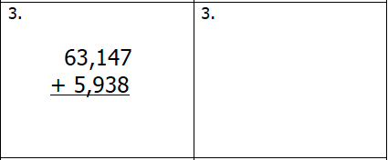

Tourists spent $114,682 during the summer of 2016 and $352,880 during the summer of 2015. Approximately how much money did tourists spend during those two summers?

www.forrestmath.weebly.com
Estimating Sums
TUESDAY
Solve the following
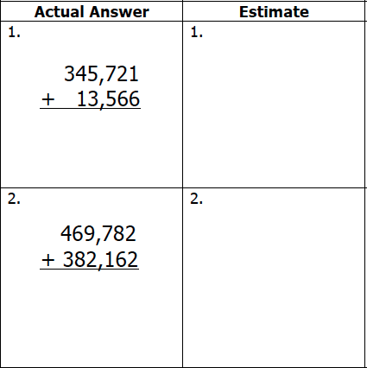

Mrs. Whetsel buys supplies for her classroom each year. Over the past 5 years she has purchased approximately 1,400 pencils. Which of the following could be the number of pencils that she actually purchased?

A) 1,299 B) 4,100

C) 1,328 D) 1,358

WEDNESDAY
Solve the following
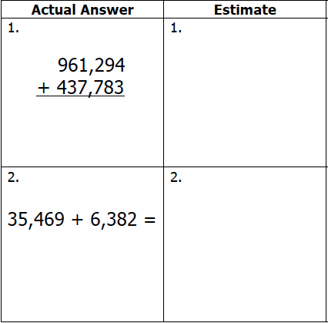

Over the weekend Mrs. Phan took a road trip to visit her family. Friday night she drove 314 miles, Saturday she drove 589 miles, and on Sunday she drove 277 miles. About how many miles did Mrs. Phan drive over the weekend?

THURSDAY – Test Practice

1. The sum of 239 and 199 is best described between 

A) 150 and 250 B) 250 and 350

C) 350 and 450 D) 450 and 550

2. The sum of 239 and 199 is best described between 

A) 150 and 250 B) 250 and 350

C) 350 and 450 D) 450 and 550

3. Sunny Citrus Orchard sold an estimate of 42,000 oranges last year to stores and fruit markets.

• About 11,000 oranges were sold to local stores.
• An estimate of 23,000 oranges were sold to stores across the country.

Which numbers represent a reasonable amount of oranges that were sold to fruit markets? Shade your choices.
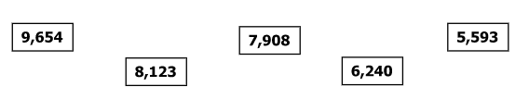Explain why each of the numbers that you did NOT select are unreasonable.

________________________________________________________________________________________

