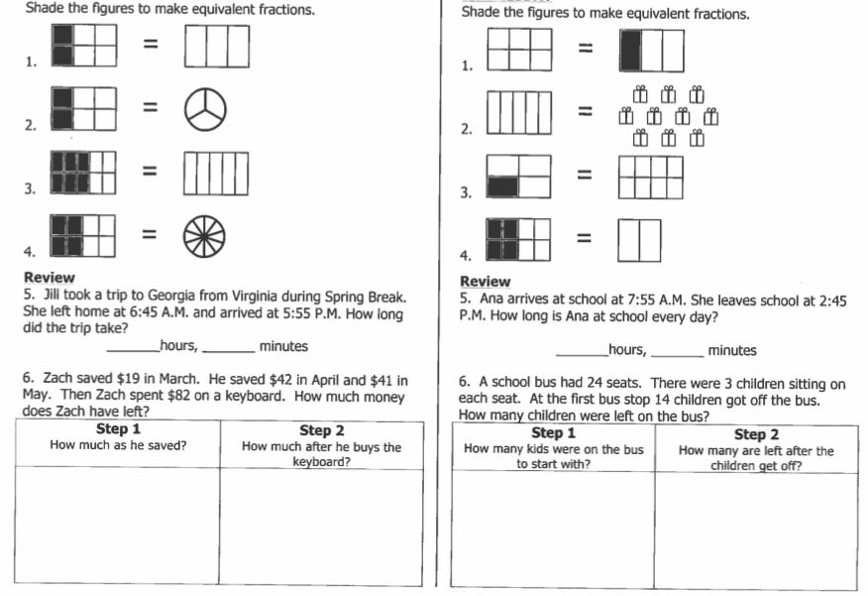

**WEDNESDAY**

**TUESDAY**

**Forrestmath.weebly.com Twitter @forrestmath1406**

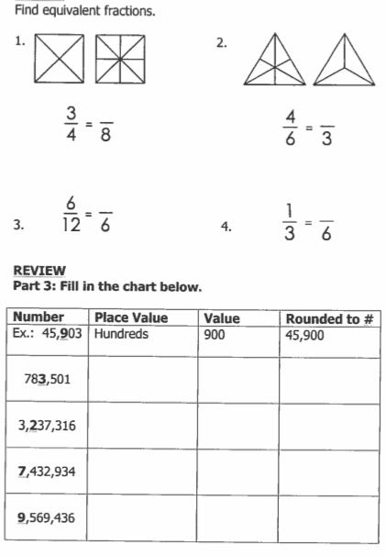**Find Equivalent Fractions**

**THURSDAY**

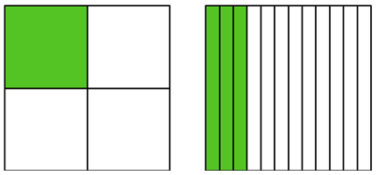

1.

1 = 3

4

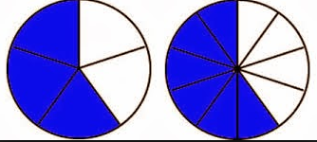2.



3 = ___

5 12

**Write equivalent fractions for 4s**

(Hint: write out your 1’s tables and 4’s tables)

|  |  |  |  |  |  |  |  |  |  |  |  |
| --- | --- | --- | --- | --- | --- | --- | --- | --- | --- | --- | --- |
| 1 |  |  |  |  |  |  |  |  |  |  |  |
| 4 |  |  |  |  |  |  |  |  |  |  |  |