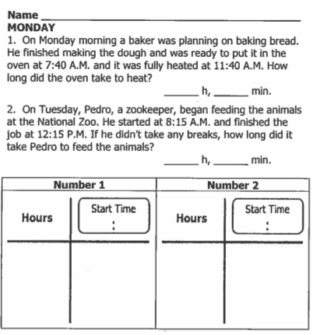

**Review: Use the bar graph below to answer the following questions**

**3.**

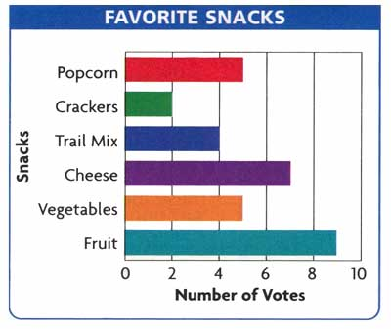**Part II: Review**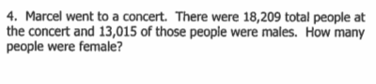

3. What is the **scale** counting by? ________

4. Is this bar graph **horizontal** or **vertical?**

5. Which snacks received more votes, popcorn and crackers or cheese and trail mix? ________________________________________

6. How many more votes did fruit receive than trail mix and crackers combined? _________________________________

[www.forrestmath.weebly.com](http://www.forrestmath.weebly.com)

