Name ________________________________
TUESDAY
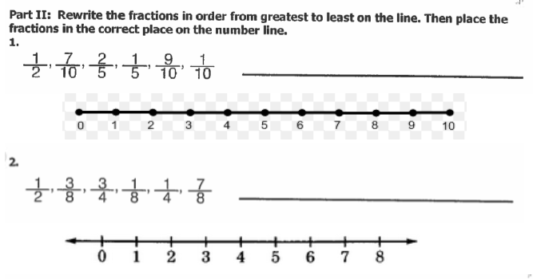
Complete the chart by listing the multiples for the following numbers:

 | x1 | x2 | x3 | x4 | x5 | x6
2
6
5
10
4
8
12

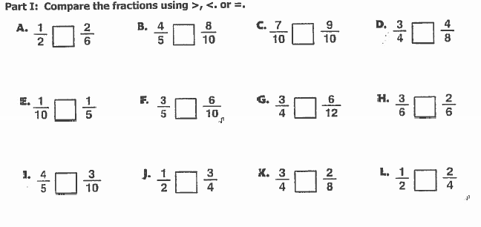

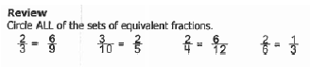

www.forrestmath.weebly.com
Comparing/Ordering Fractions HW
WEDNESDAY

Circle all of the fractions that are equivalent to ½

3^ 2# 7* 1%

8( 2$ 4* 6! @

Divide

4 d79 6d90 3f437

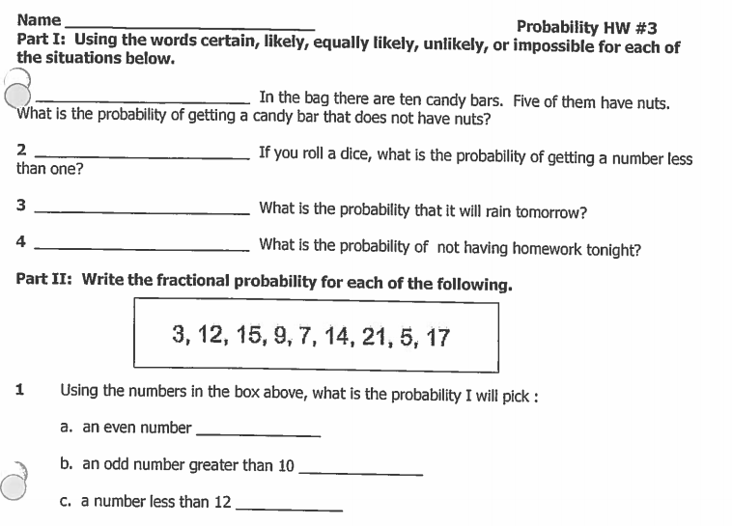
THURSDAY
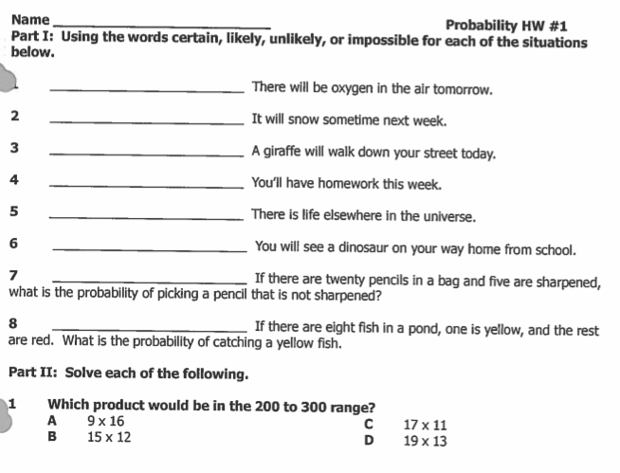

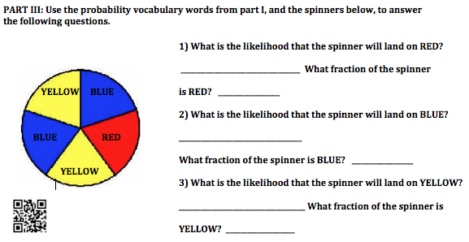

www.forrestmath.weebly.com

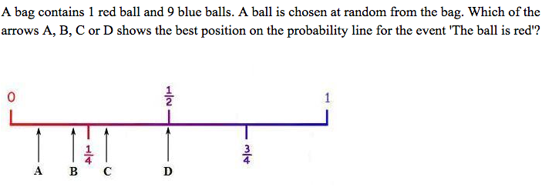

6) 12 55 12 6x7=
x x 35 x 41 x 8

