Name _________________________________
MONDAY
Part I: Vocabulary

survey table bar data axis

1) We use bars to show data in a ____________ graph.
2) You can collect data to display in a graph by conducting a
_________________.
3) Information collected in a survey and then displayed in a graph is called
_________________.
4) Before I create my graph, I can organize data using a
_________________.

Part II: Parts of a bar graph
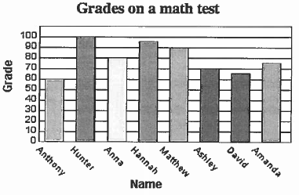
Directions: Using the graph below, identify the following parts of a bar graph.

1) Circle the title of the graph
2) Put a box around the axis labels
3) Choose any color and shade the bars that show the data
4) Put a star by the scale. What increment is the scale counting by? _____

www.forrestmath.weebly.com
Bar and Line Graph HW
TUESDAY
Part I: Analyzing (understanding) a bar graph.

5. What scores did Hannah receive on her test? _________________

6. How much higher did Matthew score than David? _______________

7. What is the combined score for Anthony, Hunter, and Ashley?
___________________
8. How many students took the test? ________________

Part II: Analyzing (understanding) a bar graph.
Directions: Use the graph from Part I to answer the questions below. Write true (T) or false (F) for each of the following based on the information in the graph.

1. _________ Anna scored twenty points more than Anthony.

2. _________ Ashley scored thirty points less than Matthew.

3. _________ Hunter and Hannah had the two highest scores in the class.

4. _________ There is a larger difference between Hunter and Anna’s test scores than between Matthew and Anthony’s.

5. Write a TRUE statement comparing David and Hannah’s test scores.
__________________________________________________________________________________________________________________________________________________________________________________________
WEDNESDAY
Part I: Analyzing a Line Graph
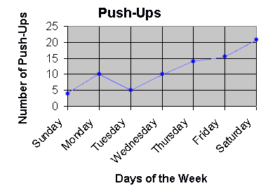

1) What is the scale counting by? _______

2) Which day had the most push ups? ______

3) What is the trend of the data between Tuesday and Saturday? ______________________

4) How many more push ups were done on Saturday than on Monday and Tuesday combined? _______

5) Create your own question using the line graph above:
________________________________________________________________________________________________________________________________________________________________________________________________________________

www.forrestmath.weebly.com
THURSDAY
Part II: Create a Line Graph
Directions: Use the data chart below to create a line graph. Be sure to use a straight edge to connect the data points.
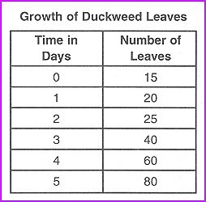

Be sure to include: title, axis labels, categories, and data points

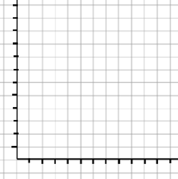

What is the trend of the data over time? _________________

